

**SOFTWARE REQUIREMENT SPECIFICATION (SRS) SIGN-OFF**

**Authorization Memorandum**

This form is to sign-off completion of the Requirement Phase for **CAMPUS MANAGEMENT SOFTWARE AT WORLD SKILL CENTER (WSC).**

World Skill Centre (WSC) acknowledges receipt of the deliverables as part of the Requirement Phase through the submission of this document.

|  |  |
| --- | --- |
| **MODULE NAME** | **Payroll Module** |

| **VERSION HISTORY** | | | |
| --- | --- | --- | --- |
| **Version** | **Author** | **Date** | **Changes** |
|  |  |  |  |
|  |  |  |  |

**WSC AUTHORITY NAME AND**  **SIGNATURE**

**SOUL AUTHORITY NAME AND**  **SIGNATURE**

Pages 1 of 97



**Sustainable Outreach And Universal**

**Leadership (SOUL) Limited**

**Software Requirement Specification (SRS)**

Of

**Payroll Module**

For Implementation of

**Campus Management Software**

at

**World Skill Center (WSC)**

**Content**

A. Abstract 3

B. Introduction 3

C. Definition, Acronyms and Abbreviations 3

D. Overview of the Document 3

E. Scope of Payroll Module 4

F. WSC Payroll Process Flow 4

G. WSC Employee Tax Exemption Process Flow 5

H. WSC Employee Expense Claim and Employee Advance Process Flow 6

I. WSC Additional Salary and Incentive Flow Process Flow 7

J. List of Screens and their descriptions 8

K. Process Definition and Requirements 10

1. Masters 10

1.1 Payroll Period 10

1.2 Income Tax Slab 11

1.3 Salary Component 14

1.4 Salary Structure 18

1.5 Employee 24

1.6Payroll Setting 33

2. Transactional Screen 36

2.1 Salary Structure Assignment 36

2.2 Salary Slip 39

2.3 Payroll Entry 46

2.4 Expense Claim Type 51

2.5 Expense Claim 52

2.6 Employee Advance 57

2.7 Journal Entry 60

2.8 Payment Entry 66

2.9 Employee Other Income 74

2.10 Employee Tax Exemption Category 75

2.11 Employee Tax Exemption Sub-Category 77

2.12 Employee Tax Exemption Declaration 78

2.13 Employee Tax Exemption Proof Submission 81

2.14 Additional Salary 84

2.15 Retention Bonus 87

2.15 Employee Incentive 89

2.16 Employee Benefit Application 90

2.17 Employee Benefit Claim 94

# Abstract

Software Requirements Gathering is one of the first phases of system development. This phase results in the Software Requirements Specification (SRS) document, which must contain a complete, concise, high-quality description of the system being considered.

# Introduction

The World Skill Center (WSC) is a premier advanced skill training institute established by the Government of Odisha, Skill Development and Technical Education Department, through the Odisha Skill Development Authority (OSDA). The WSC will impart advanced skill training in eight trades from engineering and service sectors. WSC caters primarily to induct the best talent from ITIs and Polytechnics and train them to become globally employable in emerging areas such as "Industry 4.0". WSC is housed in a state-of-the-art, 18-storey, air-conditioned building with nearly half a million square feet of space in the heart of capital city of Bhubaneswar.

With the Implementation of campus management software for WSC the goal is to streamline the operations and functions of the campus by integrating various processes, such as admissions, course registration, academic progress tracking, and financial management, HRMS, Procurement and Inventory management, etc into a unified system. The implementation also aims at providing a user-friendly interface for all stakeholders, making it easier for them to access the necessary information and complete their tasks with ease. The modules to be covered during the implementation of the software includes:

|  |  |
| --- | --- |
| Students Management Modules | Infrastructure Management |
| Academic System | Finance and Accounting System |
| Procurement & Inventory Management | Training and Placement |
| Human Resources Management System | Application Integration |

# Definition, Acronyms and Abbreviations

The following table explains the terms and abbreviations used in the document:

|  |  |
| --- | --- |
| **Abbreviation** | **Description** |
| SRS | Software Requirements Specification |
| R | Rename - When a field is Renamed |
| N | New - When a New field is Added |
| D | Delete - When an Existing field is Deleted |
| NA | Not Applicable |

# Overview of the Document

This requirement document provides a detailed overview of the functional requirements of a project. It serves as a communication tool between stakeholders, including developers, project managers, and end-users. The purpose of this requirement document is to define and document the project's objectives, scope, and expectations, and to ensure that all stakeholders have a clear understanding of what the project entails.

This document covers all the functional requirements of the **Payroll** module.This module helps in organizing the entire set-up of payroll management such as defining salary component and salary structure,configuring Income Tax Slab and Payroll Period and generating salary slip and bulk processing Payroll of the employees.

# Scope of Payroll Module

* Payroll Masters like Salary Component,Salary Structure,Income Tax Slab and Payroll Period
* Taxation including Employee Tax Exemption Declaration,Employee Tax Exemption Proof Submission and so on.
* Compensations including Additional Salary,Retention Bonus and so on.
* Bulk Processing Payroll of Employees and Salary Slip generation.

Following functionalities are covered in this SRS document:

* **Masters**
* **Salary Structure Assignment**
* **Salary Slip Generation**
* **Payroll Entry**
* **Taxation**
* **Compensation**

# WSC Payroll Process Flow

▪

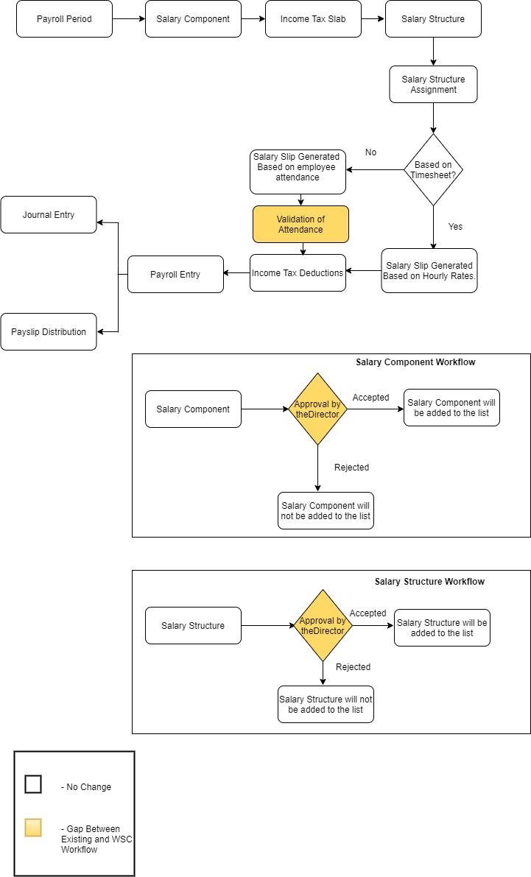

**Description:**

**Payroll Period**

Payroll Period Payroll Period helps you define Salary Structures and to calculate tax for a specific period based on applicable Income Tax Slab.

**Salary Component**

Salary Component helps you to define different components of salary.**After the salary component is made by HR,it will go for approval from Director.**

**Income Tax Slab**

In the application, you can define multiple Income Tax Slabs and link them to individual employee's salary structure.

**Salary Structure**

System allows you to define the Earnings and Deductions of a Salary Structure, Payroll frequency, and Payment Mode among other features.**After the salary structure is made by HR,it will go for approval from Director.**

**Salary Structure Assignment**

Once the Salary Structure is created and approved,different salary structure based on department,designation is assigned to Employees.

**Procedure:**

* Salary Structure is assigned to employees.
* Attendance Validation of the employees will be done.
* Salary Slip will be generated either on the basis of timesheet or on the basis of attendance.
* After the submission of Salary Slip,Journal Entry is made.

# WSC Employee Tax Exemption Process Flow

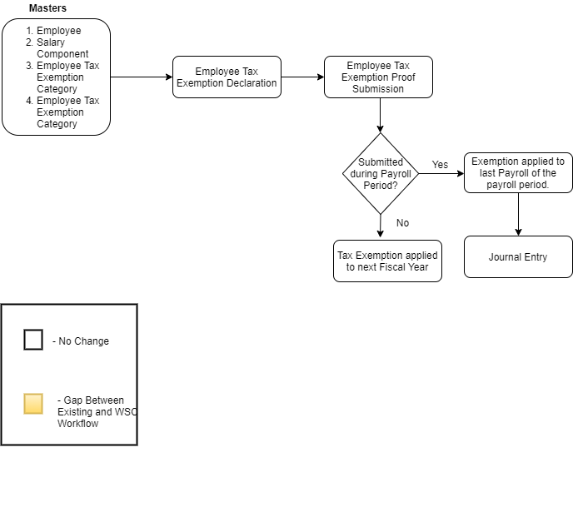

**Description:**

**Employee Tax Exemption Declaration**

At the beginning of a Payroll Period,employees can declare the amount they will be claiming from their taxable salary.

**Employee Tax Exemption Proof Submission**

Employees are required to submit proofs for all spendings they claim tax exemption for.This is done at the end of a Payroll Period.

**Procedure:**

* Employee submits proofs for all spendings they claim tax exemption for.
* If the proof is submitted during Payroll Period then,exemption is applied to the last Payroll of the Payroll Period.
* If proof is not submitted during Payroll Period then,tax exemption is applied to next Fiscal Year.

# WSC Employee Expense Claim and Employee Advance Process Flow

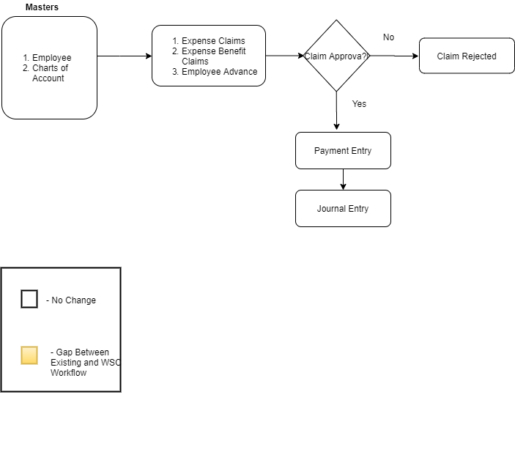

**Description:**

**Expense Claim**

Expense Claim is made when employees make expenses out of their pocket on behalf of the company.

**Expense Benefit Claim**

Employee Benefit Claim allows Employees to -

* Claim flexible benefits which are to be received lump-sum (if Salary Component is Pay Against Benefit Claim)
* Claim tax exemption for flexible benefits received pro-rata, as part of salary when Deduct Tax For Unclaimed Employee Benefits is checked in Payroll Entry / Salary Slip

**Employee Advance**

Sometimes employees go outside for company's work and company pays some amount for their expenses in advance. This is when the employee can create an Employee Advance form where details such as the Purpose of Expense and Expense Amount can be recorded.

**Procedure:**

* Employee claims for different expenses like travel expense and even advance.
* The claim is forwarded to Approver.Approver either approves or reject the same.
* Once the claim is approved,payment is made.

# WSC Additional Salary and Incentive Flow Process Flow

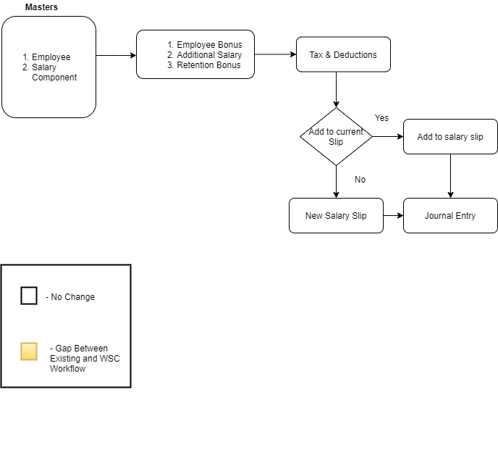

**Description:**

**Retention Bonus**

Retention bonus is a payment or reward outside of an employee's regular salary that is offered as an incentive to keep a key employee on the job.

**Additional Salary**

Additional Salary is something that an Employee receives from the company they work for, other than their usual pay.

**Procedure:**

* Employee receives additional salary or bonus from the organization.
* Tax is deducted on the same.
* There are options either to add it to the current salary slip for that month or to generate separate journal entry for it and separate salary slip.

# List of Screens and their descriptions

The following screens are present in masters and recruitment sub modules :

|  |  |  |
| --- | --- | --- |
| **Sl no** | **Existing Application** **Screen Name** | **Description** |
| Masters | | |
| 1 | Payroll Period | A Payroll Period is a period for which Employees get paid for their occupation with the Company. |
| 2 | Income Tax Slab | A Income Tax Slab is a document to define income tax rates based on different taxable income slab. |
| 3 | Salary Component | Salaries are paid by organizations to their employees in exchange for the services rendered by them. The different components that make up the Salary Structure are called as Salary Components. |
| 4 | Salary Structure | Salary Structure is the details of the salary being offered to an Employee, in terms of the breakup of the different components constituting the compensation. |
| 5 | Employee | An individual who works part-time or full-time under a contract of employment, and has recognized rights and duties of your company is your Employee. |
| 6 | Payroll Settings | Payroll Settings helps you to set-up payroll criteria. |
| Transactional Screen | | |
| 7 | Salary Structure Assignment | Salary Structure Assignment form allows you to assign a particular Salary Structure to the employee. |
| 8 | Salary Slip | A salary slip is a document issued to an employee. It contains a detailed description of the employee’s salary components and amounts. |
| 9 | Payroll Entry | Payroll Entry enables bulk processing of payroll for employees. In other words, processing salary slips of all employees in one go. |
| 10 | Expense Claim Type | It defines the different kind of expenses for which claim can be made like Internet Expenses,Medical,calls and so on. |
| 11 | Expense Claim | Expense Claim is made when employees make expenses out of their pocket on behalf of the company. |
| 12 | Employee Advance | Sometimes employees go outside for company's work and company pays some amount for their expenses in advance. This is when the employee can create an Employee Advance form where details such as the Purpose of Expense and Expense Amount can be recorded. |
| 13 | Journal Entry | A Journal Entry is an entry made in the general ledger and it indicates the affected accounts. |
| 14 | Payment Entry | Payment Entry is a record indicating that payment has been made for an invoice. |
| 15 | Employee Other Income | Employee Other Income is a document to declare other income of an employee from different sources. |
| 16 | Employee Tax Exemption Sub Category | Under each category, there could be many heads for which the exemptions are allowed. For example, in India, sub categories under 80C could be Life Insurance Premium. |
| 17 | Employee Tax Exemption Category | Exemptions from taxable salary are usually restricted to spending on particular categories decided by the Government or regulatory agencies. |
| 18 | Employee Tax Exemption Declaration | At the beginning of a Payroll Period, employees can declare the amount of exemption they will be claiming from their taxable salary |
| 19 | Employee Tax Exemption Proof Submission | Employees are required to submit proofs for all the spending they claim tax exemption for. This can be done through the Employee Tax Exemption Proof Submission document. |
| 20 | Additional Salary | Additional Salary is something that an Employee receives from the company they work for, other than their usual pay. |
| 21 | Retention Bonus | Retention bonus is a payment or reward outside of an employee's regular salary that is offered as an incentive to keep a key employee on the job. |
| 22 | Employee Incentive | Employee Incentives are a way of compensating and motivating employee performance apart from the usual salary. |
| 23 | Employee Benefit Application | Employees are entitled to flexible benefits which they can either receive pro-rata (as part of their Salary) or as a lump-sum amount when they claim the benefit. In order to choose from various flexible benefits which an Employee shall receive on a pro-rata basis, the employee should create a new Employee Benefit Application. |
| 24 | Employee Benefit Claim | Employee Benefit Claim allows Employees to - 1. Claim flexible benefits which are to be received lump-sum (if Salary Component is Pay Against Benefit Claim) 2. Claim tax exemption for flexible benefits received pro-rata, as part of salary when Deduct Tax For Unclaimed Employee Benefits is checked in Payroll Entry / Salary Slip. |

# Process Definition and Requirements

## Masters

Master Data is the central database used to define entities so that there is standardization and uniformity across the organization.These are the per-requisites for the further transactional processes.

### Payroll Period

**General Description**

The following table describes overall information about this screen:

|  |  |  |
| --- | --- | --- |
| **Description** | | 1. **A Payroll Period is a period for which Employees get paid for their occupation with the Company**. 2. Payroll Period helps you define Salary Structures and to calculate tax for a specific period based on applicable Income Tax Slab |
| **Navigation** | Home > Payroll > Masters > Payroll Period | |
| **Pre-requisites** | The system should have records in the following screen   1. Company | |
| **Existing Screen Name** | Payroll Period | |
| **New Screen Name** | No change | |

**Screenshot**

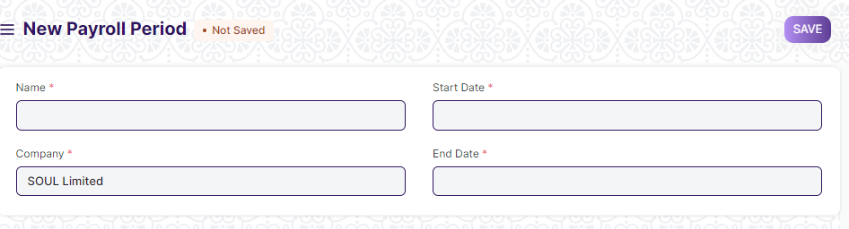

Figure 1 : Payroll Period Screen

**Field List**

The following table describes the UI fields present in this screen :

|  |  |  |  |  |  |  |
| --- | --- | --- | --- | --- | --- | --- |
| **ID** | **Field Name** | **Field Type** | **Mandatory** | **Validation/ Action** | **Remarks** | **R = Rename**  **N= New**  **D= Delete** |
| 1 | Company | Link | Yes | Link to the Master Screen “Company”. | The company will be auto-populated . |  |
| 2 | Start Date | Date | Yes |  |  |  |
| 3 | End Date | Date | Yes |  |  |  |
| 4 | Approval | Attach | Yes | Attachment will be made mandatory after the Go Live Date. |  | N |
| 4 | Payroll Periods | Table |  | This table is described below |  |  |
| Payroll Periods | | | | | | |
| **ID** | **Field Name** | **Field Type** | **Mandatory** | **Validation/ Action** | **Remarks** | **R = Rename**  **N= New**  **D= Delete** |
| 1 | Start Date | Date | Yes |  |  |  |
| 2 | End Date | Date | Yes |  |  |  |

**Users: Roles & Permission**

The following table describes the users and their roles and permissions for the screens :

|  |  |  |  |  |  |  |  |  |
| --- | --- | --- | --- | --- | --- | --- | --- | --- |
| **ID** | **Role** | **Read** | **Write** | **Create** | **Delete** | **Submit** | **Cancel** | **Amend** |
| 1 | Payroll Admin | Yes | Yes | Yes | Yes | NA | NA | NA |
| 2 | Payroll User | Yes | Yes | Yes | No | NA | NA | NA |
| 3 | HR Manager | Yes | Yes | Yes | No | NA | NA | NA |
| 4 | Employee | Yes | No | No | No | NA | NA | NA |

### Income Tax Slab

**General Description**

The Following table describe overall information about this screen:

|  |  |  |
| --- | --- | --- |
| **Description** | | 1. Income Tax Slab is a document to define income tax rates based on different taxable income slab. 2. In the application, you can define multiple Income Tax Slabs and link them to individual employee's salary structure. |
| **Navigation** | Home > Payroll> Masters > Income Tax Slab | |
| **Pre-requisites** | The system should have records in the following screen:   1. Company | |
| **Existing Screen Name** | Income Tax Slab | |
| **New Screen Name** | No change | |

**Screenshot**

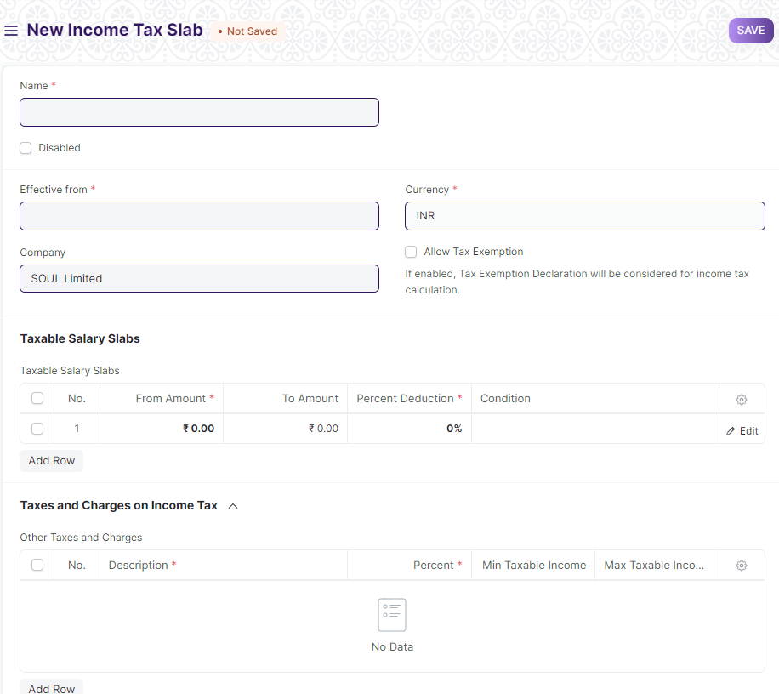

Figure 2 : Income Tax Slab Screen

**Field List**

The following table describes the UI fields present in this screen :

|  |  |  |  |  |  |  |
| --- | --- | --- | --- | --- | --- | --- |
| **ID** | **Field Name** | **Field Type** | **Mandatory** | **Validation/ Action** | **Remarks** | **R = Rename**  **N= New**  **D= Delete** |
| 1 | Disabled | Checkbox |  | If checkbox is checked,the income tax will be disabled and will be no longer be used. |  |  |
| 2 | Effective From | Date | Yes |  |  |  |
| 3 | Company | Link |  | Link to Master Screen “Company” |  |  |
| 4 | Currency | Link |  | Link to Screen “Currency” |  |  |
| 5 | Standard Tax Exemption Amount | Currency |  | If exemption is allowed, the Standard Tax Exemption Amount defined by the government can be added here. |  |  |
| 6 | Allow Tax Exemption | Checkbox |  | 1. If checkbox is checked,tax exemption can be allowed for a specific Income Tax Slab. 2. If enabled, while calculating taxes based on this tax slab, Employee Tax Exemption Declaration and Proof Submission are considered for calculating taxable income. |  |  |
| 7 | Taxable Salary Slab | Table | Yes |  | This table is described below |  |
| 8 | Other Taxes and Charges | Table |  |  | This table is described below |  |
| Taxable Salary Slab | | | | | | |
| **ID** | **Field Name** | **Field Type** | **Mandatory** | **Validation/ Action** | **Remarks** | **R = Rename**  **N= New**  **D= Delete** |
| 1 | From Amount | Currency | Yes |  |  |  |
| 2 | To Amount | Currency |  |  |  |  |
| 3 | Percent Deduction | Percent | Yes |  |  |  |
| 4 | Conditions | Code |  |  |  |  |
| Other Taxes and Charges | | | | | | |
| **ID** | **Field Name** | **Field Type** | **Mandatory** | **Validation/ Action** | **Remarks** | **R = Rename**  **N= New**  **D= Delete** |
| 1 | Description | Text | Yes |  |  |  |
| 2 | Percent | Percent | Yes |  |  |  |
| 3 | Conditions | Code |  |  |  |  |
| 4 | Min Taxable Income | Currency |  |  |  |  |
| 5 | Max Taxable Income | Currency |  |  |  |  |

**Description of Table**

**Taxable Salary Slab**

In the Tax Slab table, you can define the rate for different income slabs. To define slab, From Amount and To Amount should be entered. For the first slab, From Amount is optional and for the last slab, To Amount is optional. Both the amount is inclusive while evaluating tax based on taxable income.

**Other Taxes and Charges**

If other taxes are applicable on calculated income tax, you can enter those using this table. You can also define the min and max taxable amount for which this tax will be applicable. For example, Health and Education Cess is applied additionally on income tax to everyone in India.

**Users: Roles & Permission**

The following table describes the users and their roles and permissions for the screens :

|  |  |  |  |  |  |  |  |  |
| --- | --- | --- | --- | --- | --- | --- | --- | --- |
| **ID** | **Role** | **Read** | **Write** | **Create** | **Delete** | **Submit** | **Cancel** | **Amend** |
| 1 | Payroll Admin | Yes | Yes | Yes | Yes | Yes | Yes | Yes |
| 2 | Payroll User | Yes | Yes | Yes | No | Yes | No | No |
| 3 | HR Manager | Yes | Yes | Yes | No | Yes | No | No |
| 4 | Employee | Yes | No | No | No | NA | No | No |

### Salary Component

**General Description**

The Following table describe overall information about this screen:

|  |  |  |
| --- | --- | --- |
| **Description** | | 1. **Salaries are paid by organizations to their employees in exchange for the services rendered by them. The different components that make up the Salary Structure are called as Salary Components**. 2. Salary paid to the employees comprises of several different components, such as basic salary, allowances, arrears, etc. |
| **Navigation** | Home > Payroll> Masters > Salary Component. | |
| **Pre-requisites** | The system should have records in the following screen:   1. Company 2. Charts of Account | |
| **Existing Screen Name** | Salary Component | |
| **New Screen Name** | No change | |

**Screenshot**

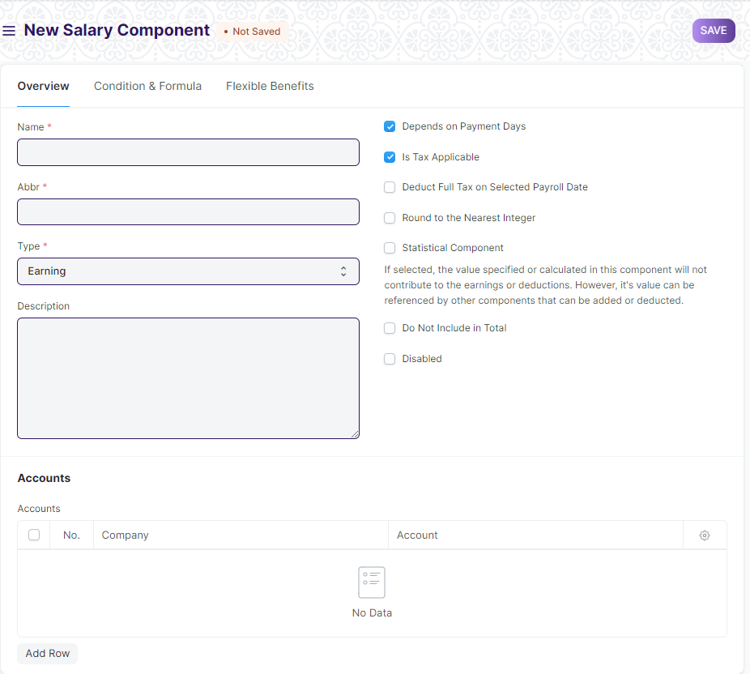

Figure 3 : Salary Component Screen

**Field List**

The following table describes the UI fields present in this screen :

|  |  |  |  |  |  |  |
| --- | --- | --- | --- | --- | --- | --- |
| **ID** | **Field Name** | **Field Type** | **Mandatory** | **Validation/ Action** | **Remarks** | **R = Rename**  **N= New**  **D= Delete** |
| 1 | Name | Text | Yes |  |  |  |
| 2 | Abbr | Text | Yes |  |  |  |
| 3 | Type | Dropdown | Yes | Options:   1. Earning 2. Deduction |  |  |
| 4 | Description | Text |  |  |  |  |
| 5 | Component Type | Dropdown |  | Options:  1.Provident Fund  2.Additional Provident Fund  3.Provident Fund Loan  4.Professional Tax |  |  |
| 6 | Depends on Payment | Checkbox |  | If checkbox is checked ,the salary component will be calculated based on the number of working days. | When Type is **“Earning or Deduction”** |  |
| 7 | Is Tax Applicable | Checkbox |  | If checkbox is checked ,tax to be applied on the salary component. | When Type is **“Earning”** |  |
| 8 | Is Income Tax Component | Checkbox |  | If checkbox is checked , | When Type is **“ Deduction”** |  |
| 9 | Deduct Full Tax on Selected Payroll Date | Checkbox |  | If checkbox is checked ,the component is used in Additional Salary, the tax amount applicable on the additional amount will be deducted on the specific payroll month. | When Type is **“Earning”** |  |
| 10 | Variable Based On Taxable Salary | Checkbox |  | If checkbox is checked ,The component is calculated automatically on taxable income based on applicable Income Tax Slab | When Type is **“ Deduction”** |  |
| 11 | Exempted from Income Tax | Checkbox |  | If checkbox is checked , the full amount will be deducted from taxable income before calculating income tax without any [declaration](https://frappehr.com/docs/v14/user/manual/en/human-resources/employee-tax-exemption-declaration) or [proof submission](https://frappehr.com/docs/v14/user/manual/en/human-resources/employee-tax-exemption-proof-submission). | When Type is **“ Deduction”** |  |
| 12 | Round to the Nearest Integer | Checkbox |  | If checkbox is checked ,the amount of this Salary Component to the nearest integer. | When Type is **“Earning or Deduction”** |  |
| 13 | Statistical Component | Checkbox |  | If checkbox is checked ,the value specified or calculated in this component will not contribute to the earnings or deductions. | When Type is **“Earning or Deduction”** |  |
| 14 | Do Not Include in Total | Checkbox |  | If checkbox is checked , the Salary Component is not included in the Total Salary. | When Type is **“Earning or Deduction”** |  |
| 15 | Disabled | Checkbox |  | If checkbox is checked ,salary component is disabled and cannot be used in the salary structure. |  |  |
| 16 | Accounts | Table |  |  | This table is described below. |  |
| Tab Break(Condition and Formula) | | | | | | |
| 17 | Condition | Code |  |  |  |  |
| 18 | Amount | Currency |  |  |  |  |
| 19 | Amount based on formula | Checkbox |  | If checkbox is checked ,amount will be calculated on the basis of formula and condition. |  |  |
| 20 | Formula | Code |  |  |  |  |
| 21 | Help | HTML |  |  |  |  |
| Tab Break(Condition and Formula) | | | | | | |
| 22 | Is Flexible Benefit | Checkbox |  | If checkbox is checked ,user can set maximum benefit (yearly) |  |  |
| 23 | Max Benefit Amount (Yearly) | Currency |  |  |  |  |
| 24 | Pay Against Benefit Claim | Checkbox |  | If checkbox is checked ,pay this benefit via the [Employee Benefit Claim](https://frappehr.com/docs/v14/user/manual/en/human-resources/employee-benefit-claim). |  |  |
| 25 | Only Tax Impact (Cannot Claim But Part of Taxable Income) | Checkbox |  | If checkbox is checked ,the flexible benefit will be part of taxable income. |  |  |
| 26 | Create Separate Payment Entry Against Benefit Claim | Checkbox |  | If checkbox is checked ,it will let you create a separate payment entry against the Benefit Claim. |  |  |
| Accounts | | | | | | |
| **ID** | **Field Name** | **Field Type** | **Mandatory** | **Validation/ Action** | **Remarks** | **R = Rename**  **N= New**  **D= Delete** |
| 1 | Company | Link |  | Link to master screen “company” |  |  |
| 2 | Account | Link |  | Link to master screen “account” |  |  |

**Action:**

1. **Workflow:**
2. HR manager will add the component.
3. Once the component is added by HR manager,it will go to the Director for the Approval.

**Users: Roles & Permission**

The following table describes the users and their roles and permissions for the screens :

|  |  |  |  |  |  |  |  |  |
| --- | --- | --- | --- | --- | --- | --- | --- | --- |
| **ID** | **Role** | **Read** | **Write** | **Create** | **Delete** | **Submit** | **Cancel** | **Amend** |
| 1 | Payroll Admin | Yes | Yes | Yes | Yes | NA | NA | NA |
| 2 | Payroll User | Yes | Yes | Yes | No | NA | NA | NA |
| 3 | HR Manager | Yes | Yes | Yes | No | NA | NA | NA |
| 4 | Employee | No | No | No | No | NA | NA | NA |

### Salary Structure

**General Description**

The Following table describe overall information about this screen:

|  |  |  |
| --- | --- | --- |
| **Description** | | 1. Salary Structure is the details of the salary being offered to an Employee, in terms of the breakup of the different components constituting the compensation. 2. System allows you to define the Earnings and Deductions of a Salary Structure, Payroll frequency, and Payment Mode among other features. |
| **Navigation** | Home > Payroll> Masters > Salary Structure | |
| **Pre-requisites** | The system should have records in the following screen:   1. Salary Component | |
| **Existing Screen Name** | Salary Structure | |
| **New Screen Name** | No change | |

**Screenshot**

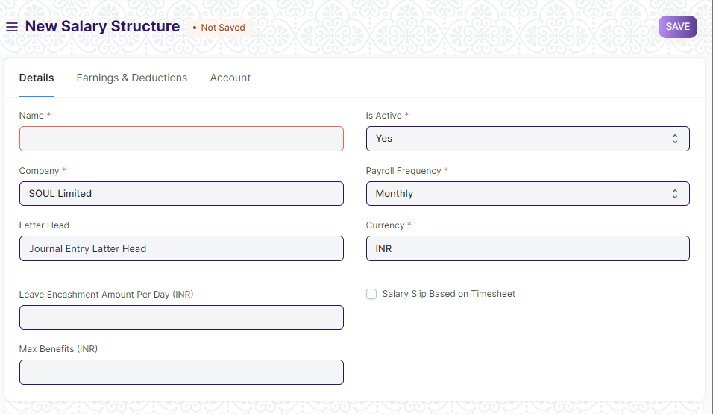

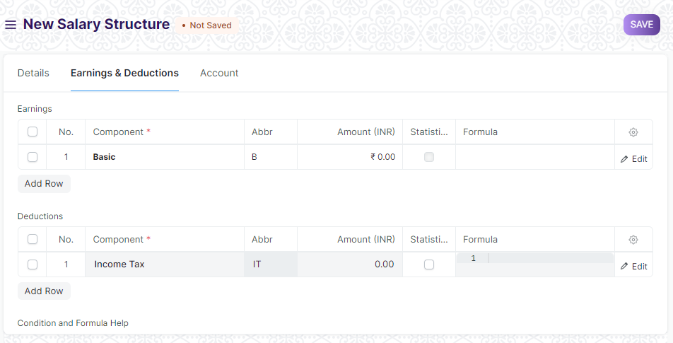

Figure 4 : Salary Structure Screen

**Field List**

The following table describes the UI fields present in this screen :

|  |  |  |  |  |  |  |
| --- | --- | --- | --- | --- | --- | --- |
| **ID** | **Field Name** | **Field Type** | **Mandatory** | **Validation/ Action** | **Remarks** | **R = Rename**  **N= New**  **D= Delete** |
|  | Company | Link | Yes | Link to master screen “Company” |  |  |
|  | Employment Type | Link | Yes | Link to master screen “Employment Type” |  | N |
|  | Letter Head | Link |  |  |  |  |
|  | Is Active | Dropdown | Yes | Option:   1. Yes 2. No |  |  |
|  | Is Default | Dropdown |  | Option:   1. Yes 2. No |  |  |
|  | Payroll Frequency | Dropdown |  | Option:   1. Monthly 2. Fortnightly 3. Bimonthly 4. Weekly 5. Daily |  |  |
|  | Currency | Link | Yes |  |  |  |
|  | Leave Encashment Amount Per Day | Currency |  |  |  |  |
|  | Max Benefits (Amount) | Currency |  |  |  |  |
|  | Salary Slip Based on Timesheet | Checkbox |  | If the checkbox is checked, the salary structure will be made on the basis of timesheet. |  |  |
|  | Salary Component | Link |  | This field will appear when the “Salary slip based on timesheet” is checked. |  |  |
|  | Hour Rate | Currency |  | This field will appear when the “Salary slip based on timesheet” is checked. |  |  |
| Tab Break (Earning & Deduction) | | | | | | |
| 13 | Earnings | Table |  |  | This table is described below. |  |
| 14 | Deductions | Table |  |  | This table is described below. |  |
| 15 | Total Earning | Currency |  |  |  |  |
| 16 | Total Deduction | Currency |  |  |  |  |
| 17 | Net Pay | Currency |  |  |  |  |
| Tab Break (Account) | | | | | | |
| 18 | Mode of Payment | Link |  | Link to “mode of payment” |  |  |
| 19 | Payment Account | Link |  | Link to “Account” |  |  |
| Earnings | | | | | | |
| **ID** | **Field Name** | **Field Type** | **Mandatory** | **Validation/ Action** | **Remarks** | **R = Rename**  **N= New**  **D= Delete** |
| 1. 1 | Component | Link | Yes | Link to master screen “Company” |  |  |
| 1. 2 | Abbr | Text |  |  |  |  |
|  | Amount | Currency |  | Auto-fetched on the basis of selected “component” |  |  |
|  | Year to date | Currency |  |  |  |  |
|  | Additional Salary | Link |  | Link to screen “Additional Salary” |  |  |
|  | Is Recurring addition | Checkbox |  | Auto-fetched on the basis of selected “component” |  |  |
|  | Satistical Component | Checkbox |  | Auto-fetched on the basis of selected “component” |  |  |
|  | Depends on Payment Days | Checkbox |  | Auto-fetched on the basis of selected “component” |  |  |
|  | Exempted from Income Tax | Checkbox |  | Auto-fetched on the basis of selected “component” |  |  |
|  | Is Tax Applicable | Checkbox |  | Auto-fetched on the basis of selected “component” |  |  |
|  | Is Flexible Benefit | Checkbox |  | Auto-fetched on the basis of selected “component” |  |  |
|  | Variable based on Taxable salary | Checkbox |  | Auto-fetched on the basis of selected “component” |  |  |
|  | Do not include in the total | Checkbox |  | Auto-fetched on the basis of selected “component” |  |  |
|  | Deduct Full Tax on Selected Payroll Date. | Checkbox |  | Auto-fetched on the basis of selected “component” |  |  |
|  | Condition | Code |  |  |  |  |
|  | Amount based on formula | Checkbox |  |  |  |  |
|  | Default Amount | Currency |  |  |  |  |
| 18 | Additional Amount | Currency |  |  |  |  |
| 19 | Tax on flexible benefit | Currency |  |  |  |  |
| 20 | Tax on additional salary | Currency |  |  |  |  |
| Deduction | | | | | | |
| **ID** | **Field Name** | **Field Type** | **Mandatory** | **Validation/ Action** | **Remarks** | **R = Rename**  **N= New**  **D= Delete** |
| 1. 1 | Component | Link | Yes | Link to master screen “Company” |  |  |
| 1. 2 | Abbr | Text |  |  |  |  |
|  | Amount | Currency |  | Auto-fetched on the basis of selected “component” |  |  |
|  | Year to date | Currency |  |  |  |  |
|  | Additional Salary | Link |  | Link to screen “Additional Salary” |  |  |
|  | Is Recurring addition | Checkbox |  | Auto-fetched on the basis of selected “component” |  |  |
|  | Satistical Component | Checkbox |  | Auto-fetched on the basis of selected “component” |  |  |
|  | Depends on Payment Days | Checkbox |  | Auto-fetched on the basis of selected “component” |  |  |
|  | Exempted from Income Tax | Checkbox |  | Auto-fetched on the basis of selected “component” |  |  |
|  | Is Tax Applicable | Checkbox |  | Auto-fetched on the basis of selected “component” |  |  |
|  | Is Flexible Benefit | Checkbox |  | Auto-fetched on the basis of selected “component” |  |  |
|  | Variable based on Taxable salary | Checkbox |  | Auto-fetched on the basis of selected “component” |  |  |
|  | Do not include in the total | Checkbox |  | Auto-fetched on the basis of selected “component” |  |  |
|  | Deduct Full Tax on Selected Payroll Date. | Checkbox |  | Auto-fetched on the basis of selected “component” |  |  |
|  | Condition | Code |  |  |  |  |
|  | Amount based on formula | Checkbox |  |  |  |  |
|  | Default Amount | Currency |  |  |  |  |
| 18 | Additional Amount | Currency |  |  |  |  |
| 19 | Tax on flexible benefit | Currency |  |  |  |  |
| 20 | Tax on additional salary | Currency |  |  |  |  |
|  | **Assign Salary Structure** | Button |  | This button will appear once the salary structure is save and submitted.  Using this button user can assign the current salary structure to the Employee. |  |  |
|  | **Assign to Employees** | Button |  | This button will appear once the salary structure is save and submitted.  Using this button user can assign the current salary structure to multiple Employees(using filters like department,designation and so on) |  |  |
|  | **Preview Salary Slip** |  |  | This button will appear once the salary structure is save and submitted.  Using this button user can preview the salary slip associated with the current salary structure |  |  |

**Action:**

1. **Workflow:**
2. HR manager will add the Salary Structure.
3. Once the component is added by HR manager,it will go to the Director for the Approval.

**Users: Roles & Permission**

The following table describes the users and their roles and permissions for the screens :

|  |  |  |  |  |  |  |  |  |
| --- | --- | --- | --- | --- | --- | --- | --- | --- |
| **ID** | **Role** | **Read** | **Write** | **Create** | **Delete** | **Submit** | **Cancel** | **Amend** |
| 1 | Payroll Admin | Yes | Yes | Yes | Yes | Yes | Yes | Yes |
| 2 | Payroll User | Yes | Yes | Yes | No | Yes | No | No |
| 3 | HR Manager | Yes | Yes | Yes | No | Yes | No | No |
| 4 | Employee | Yes | No | No | No | NA | No | No |

### Employee

**General Description**

The Following table describe overall information about this screen:

|  |  |  |
| --- | --- | --- |
| **Description** | | 1. Employee is an individual who works part-time or full-time under a contract of employment, and has recognized rights and duties of your company. 2. User can manage the Employee master. It captures the demographic, personal and professional details, joining and leave details, etc. of the Employee. |
| **Navigation** | Home > HRMS> Employee> Employee | |
| **Pre-requisites** | The system should have records in the following screen:   1. Employment Type 2. Department 3. Employee Grade 4. Branch 5. Designation 6. Leave Policy 7. Holiday List 8. Shift Type 9. Employee Health Insurance 10. Job Applicant(Optional) | |
| **Existing Screen Name** | Employee | |
| **New Screen Name** | No change | |

**Screenshot**

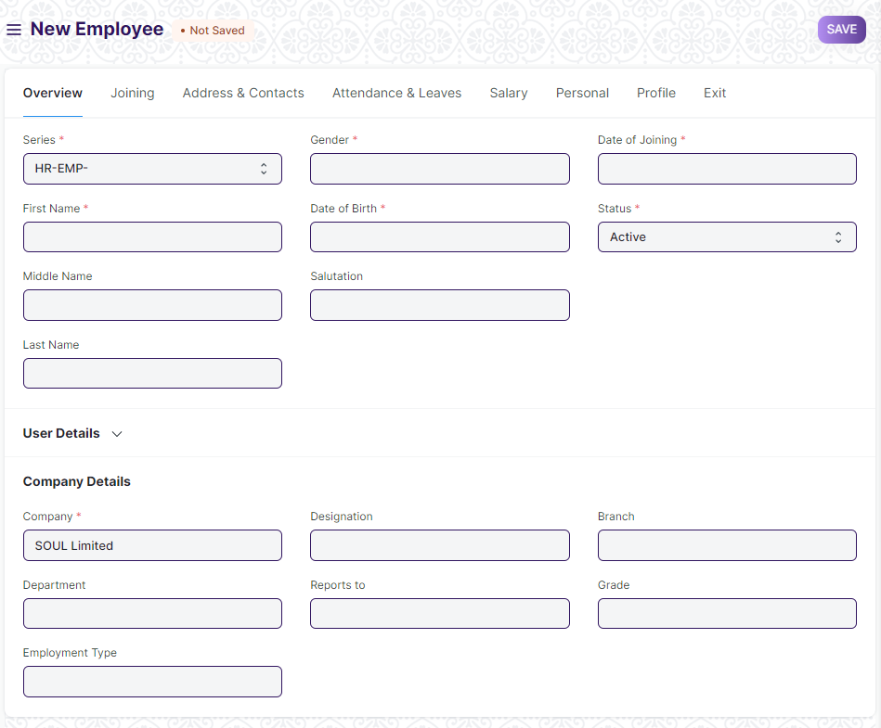

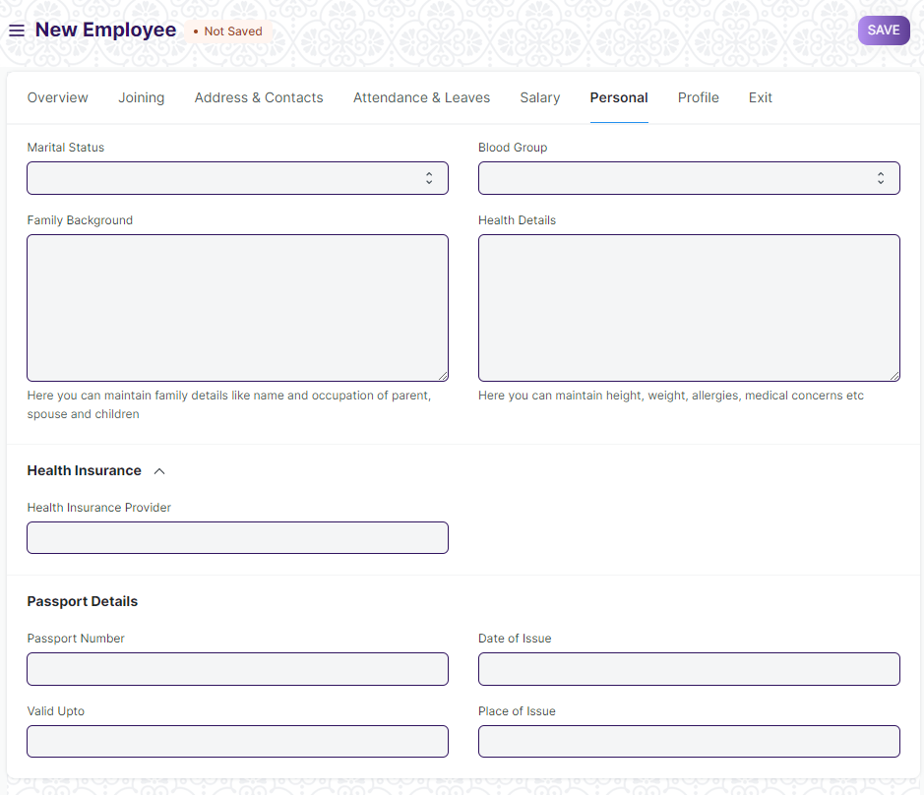

Figure 5 : Employee Screen

**Field List**

The following table describes the UI fields present in this screen :

|  |  |  |  |  |  |  |
| --- | --- | --- | --- | --- | --- | --- |
| **ID** | **Field Name** | **Field Type** | **Mandatory** | **Validations/Action** | **Remarks** | R=Rename  N= New  D= Delete |
| 1 | Employee | Text |  |  |  |  |
| 2 | Series | Dopdown | Yes |  |  |  |
| 3 | First Name | Text | Yes |  |  |  |
| 4 | Middle Name | Text |  |  |  |  |
| 5 | Last Name | Text |  |  |  |  |
| 6 | Full Name | Text |  |  |  |  |
| 7 | Gender | Link | Yes |  |  |  |
| 8 | Date of Birth | Date | Yes |  |  |  |
| 9 | Category | Link |  | Link to Master Screen “Category” |  |  |
| 10 | Salutation | Link |  | Link to Screen”Salutation” |  |  |
| 11 | Date of Joining | Date |  |  |  |  |
| 12 | Image | Attach Image |  |  |  |  |
| 13 | Status | Dopdown | Yes | **Options:**   1. Active 2. Inactive 3. Suspended 4. Left |  |  |
| 14 | User ID | Link |  | Link to the Screen”User” |  |  |
| 15 | Create User | Button |  |  |  |  |
| 16 | Create User Permission | Checkbox |  | If checked “User Permission”  restrictions will be created for the employee. |  |  |
| 17 | Company | Link | Yes | The field will be auto-populated as per the settings. |  |  |
| 18 | Department | Link |  | Link to the master screen Department. |  |  |
| 19 | Employment Type | Link |  | Link to the master screen Employment Type |  |  |
| 20 | Employee Number | Text |  |  |  |  |
| 21 | Designation | Link |  | Link to the master screen Designation. |  |  |
| 22 | Reports to | Link |  | Link to master screen Employee |  |  |
| 23 | Branch | Link |  | Link to master screen Branch |  |  |
| 24 | Grade | Link |  | Link to master screen Employee Grade. |  |  |
| Tab Break | | | | | | |
| 25 | Job Applicant | Link |  | Link to screen Job Applicant. |  |  |
| 26 | Offer Date | Date |  |  |  |  |
| 27 | Confirmation Date | Date |  |  |  |  |
| 28 | Contract End Date | Date |  |  |  |  |
| 29 | Notice (days) | Number |  |  |  |  |
| 30 | Date Of Retirement | Date |  |  |  |  |
| Tab Break | | | | | | |
| 31 | Mobile | Text |  |  |  |  |
| 32 | Personal Email | Text |  |  |  |  |
| 33 | Company Email | Text |  |  |  |  |
| 34 | Preferred Contact Email | Dopdown |  | **Options:**   1. Company Email 2. Personal Email   3.User ID |  |  |
| 35 | Preferred Email | Text |  |  |  |  |
| 36 | Unsubscribed | Checkbox |  |  |  |  |
| 37 | Current Address | Small Text |  |  |  |  |
| 38 | Current Address Is | Dopdown |  | Options:   1. Rented 2. Owned |  |  |
| 39 | Permanent Address | Small Text |  |  |  |  |
| 40 | Permanent Address Is | Dopdown |  | Options:   1. Rented 2. Owned |  |  |
| 41 | Emergency Contact Name | Text |  |  |  |  |
| 42 | Emergency Phone | Text |  |  |  |  |
| 43 | Relation | Text |  |  |  |  |
| Tab Break | | | | | | |
| 44 | Attendance Device ID (Biometric/RF tag ID) | Text |  |  |  |  |
| 45 | Holiday List | Link |  | Link to the master screen “Holiday List” |  |  |
| 46 | Default Shift | Link |  | Link to the master screen “Shift Type” |  |  |
| 47 | Expense Approver | Link |  | Link to the screen “User” |  |  |
| 48 | Leave Approver | Link |  | Link to the screen “User” |  |  |
| 49 | Shift Request Approver | Link |  | Link to the screen “User” |  |  |
| Tab Break | | | | | | |
| 50 | Cost to Company (CTC) | Currency |  |  |  |  |
| 51 | Salary Currency | Link |  |  |  |  |
| 52 | Salary Mode | Dopdown |  | Options:   1. Bank 2. Cash 3. Cheque |  |  |
| 53 | Payroll Cost Center | Link |  | Link to the screen “Cost Center” |  |  |
| 54 | PAN Number | Text |  |  |  |  |
| 55 | Aadhar Number | Text |  |  |  |  |
| 56 | Provident Fund Account | Text |  |  |  |  |
| 57 | Bank Name | Text |  |  |  |  |
| 58 | Bank A/C No. | Text |  |  |  |  |
| 59 | IFSC Code | Text |  |  |  |  |
| 60 | MICR Code | Text |  |  |  |  |
| 61 | Marital Status | Dopdown |  | Options:  1 Single  2 Married  3 Divorced  4 Widowed |  |  |
| 62 | Family Background | Small Text |  |  |  |  |
| 63 | Family Background Details | Table |  | This table is described below |  |  |
| 64 | Health Insurance Details | Table |  | This table is described below |  |  |
| 65 | Blood Group | Dopdown |  | Options:  A+  A-  B+  B-  AB+  AB-  O+  O- |  |  |
| 66 | Health Details | Small Text |  |  |  |  |
| 67 | Health Insurance Provider | Link |  | Link to screen Employee Insurance Provider |  |  |
| 68 | Health Insurance No | Text |  |  |  |  |
| 69 | Passport Number | Text |  |  |  |  |
| 70 | Valid Upto | Date |  |  |  |  |
| 71 | Date of Issue | Date |  |  |  |  |
| 72 | Place of Issue | Text |  |  |  |  |
| 73 | Visa Details | Table |  | This table is described below |  |  |
| 74 | Bio / Cover Letter | Text Editor |  |  |  |  |
| 75 | Education Details | Table |  | This table is described below |  |  |
| 76 | External Work History | Table |  | This table is described below |  |  |
| 77 | Internal Work History | Table |  | This table is described below |  |  |
| 78 | Additional Charges | Table |  | This table is described below |  |  |
| 79 | Criminal Cases(If any) | Table |  | This table is described below |  |  |
| 80 | Resignation Letter Date | Date |  |  |  |  |
| 81 | Relieving Date | Date |  |  |  |  |
| 82 | Exit Interview Held On | Date |  |  |  |  |
| 83 | New Workplace | Text |  |  |  |  |
| 84 | Leave Encashed? | Dopdown |  |  |  |  |
| 85 | Encashment Date | Date |  |  |  |  |
| 86 | Reason for Leaving | Small Text |  |  |  |  |
| 87 | Feedback | Small Text |  |  |  |  |
| 88 | Old Parent | Text |  |  |  |  |
| **Family Background Details** | | | | | | |
| **ID** | **Field Name** | **Field Type** | **Mandatory** | **Validation/ Action** | **Remarks** | **R= Rename**  **N= New**  **D= Delete** |
| 1 | Name | Text | Yes |  |  |  |
| 2 | Relation | Text | Yes |  |  |  |
| 3 | Occupation | Text | Yes |  |  |  |
| 4 | Gender | Link | Yes | Link to the screen Gender |  |  |
| 5 | Contact | Number | Yes |  |  |  |
| 6 | Date of Birth | Date | Yes |  |  |  |
| 7 | Annual Income | Number |  |  |  |  |
| Health Details | | | | | | |
| **ID** | **Field Name** | **Field Type** | **Mandatory** | **Validation/ Action** | **Remarks** | **R = Rename**  **N= New**  **D= Delete** |
| 1 | Disease name | Text | Yes |  |  |  |
| 2 | Description | Text Editor | Yes |  |  |  |
| 3 | Recommendation by Physician | Text |  |  |  |  |
| 4 | Attach |  |  |  |  |  |
| **Visa Details** | | | | | | |
| **ID** | **Field Name** | **Field Type** | **Mandatory** | **Validation/ Action** | **Remarks** | **R = Rename**  **N= New**  **D= Delete** |
| 1 | Visa Number | Text | Yes |  |  |  |
| 2 | Visa Type | Dropdown | Yes | **Options:**   1. Tourist Visa(T) 2. Business Visa(B) 3. Employment Visa(E) 4. Medical Visa(Med) 5. Conference(C) 6. Entry Visa(X) |  |  |
| 3 | Visa Sub Type | Dropdown |  | **Options:**   1. T-1 2. T-2 3. T-3 4. B-1 5. B-2 6. B-3 7. B-4 8. B-5 9. B-6 10. B-7 11. B-Sports 12. B-1X 13. B-2X 14. B-3X 15. B-4X 16. E-1 17. E-2 18. E-3 19. E-4 20. E-5 21. E-1X 22. E-2X 23. E-3X 24. E-4X 25. E-5X 26. F 27. C-1 28. C-2 29. X-1 30. X-2 31. X-Misc |  |  |
| 4 | Date of issue | Date | Yes | Link to the screen Gender |  |  |
| 5 | Date of Expiry | Date | Yes |  |  |  |
| 6 | Service Number | Text |  |  |  |  |
| 7 | Number of entries | Number |  |  |  |  |
| **Education Qualification Details** | | | | | | |
| **ID** | **Field Name** | **Type** | **Mandatory** | **Validation/ Action** | **Remarks** | **R=Rename**  **N= New**  **D= Delete** |
| 1 | School/University | Small Text | Yes |  |  |  |
| 2 | Qualification | Text | Yes |  |  |  |
| 3 | Level | Dopdown | Yes | **Options:**   1. Graduate 2. Post Graduate 3. Under Graduate |  |  |
| 4 | Year of Passing | Number | Yes |  |  |  |
| 5 | Class / Percentage | Number | Yes |  |  |  |
| 6 | Major/Optional Subjects | Text | Yes |  |  |  |
| **External Work History** | | | | | | |
| **ID** | **Field Name** | **Field Type** | **Mandatory** | **Validation/ Action** | **Remarks** | **R = Rename**  **N= New**  **D= Delete** |
| 1 | Company | Text | Yes | Company will be auto-populated on the basis of setting. |  |  |
| 2 | Designation | Text | Yes |  |  |  |
| 3 | Salary | Currency | Yes |  |  |  |
| 4 | Address | Small Text | Yes |  |  |  |
| 5 | Contact | Text | Yes |  |  |  |
| 6 | Total Experience | Text | Yes |  |  |  |
| **Internal Work History** | | | | | | |
| **ID** | **Field Name** | **Field Type** | **Mandatory** | **Validation/ Action** | **Remarks** | **R = Rename**  **N= New**  **D= Delete** |
| 1 | Branch | Link |  | Link to master screen Branch |  |  |
| 2 | Department | Link |  | Link to master screen Department |  |  |
| 3 | Designation | Link |  | Link to master screen Designation |  |  |
| 4 | From Date | Date |  |  |  |  |
| 5 | To Date | Date |  |  |  |  |
| 6 | Employee Re-engagement ID | Link |  |  |  |  |
| **Additional Charges** | | | | | | |
| **ID** | **Field Name** | **Field Type** | **Mandatory** | **Validation/ Action** | **Remarks** | **R = Rename**  **N= New**  **D= Delete** |
| 1 | Project Name | Text |  |  |  |  |
| 2 | Place of Work | Text |  |  |  |  |
| 3 | Description of Work | Text |  |  |  |  |
| 4 | Role | Link |  |  |  |  |
| 5 | Assigned By | Link |  |  |  |  |
| 6 | Start Date | Date |  |  |  |  |
| 7 | End Date | Date |  |  |  |  |
| 8 | Office Order | Attach |  |  |  |  |
| **Criminal Cases(if any)** | | | | | | |
| **ID** | **Field Name** | **Field Type** | **Mandatory** | **Validation/ Action** | **Remarks** | **R = Rename**  **N= New**  **D= Delete** |
| 1 | Description | Text |  |  |  |  |
| 2 | Status | Dropdown |  | Options:  Resolved  Pending  Ongoing |  |  |

**Users: Roles & Permission**

The following table describes the users and their roles and permissions for the screens :

|  |  |  |  |  |  |  |  |  |
| --- | --- | --- | --- | --- | --- | --- | --- | --- |
| **ID** | **Role** | **Read** | **Write** | **Create** | **Delete** | **Submit** | **Cancel** | **Amend** |
| 1 | Payroll Admin | Yes | Yes | Yes | Yes | NA | NA | NA |
| 2 | Payroll User | Yes | Yes | Yes | No | NA | NA | NA |
| 3 | HR Manager | Yes | Yes | Yes | No | NA | NA | NA |
| 4 | Employee | Yes | No | No | No | NA | NA | NA |

### 1.6Payroll Setting

**General Description**

The Following table describe overall information about this screen:

|  |  |
| --- | --- |
| Description | 1. Payroll Settings helps you to set-up payroll criteria. |
| **Navigation** | Home > Payroll> Settings> Payroll Settings |
| **Pre-requisites** | The system should have records in the following screen:   1. Company |
| **Existing Screen Name** | Payroll Settings |
| **New Screen Name** | No change |

**Screenshot**

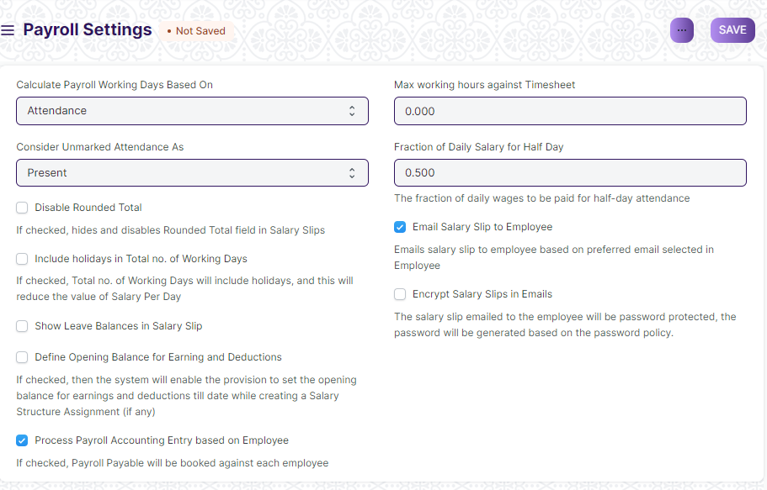

Figure 6 : Payroll Settings Screen

**Field List**

The following table describes the UI fields present in this screen :

|  |  |  |  |  |  |  |
| --- | --- | --- | --- | --- | --- | --- |
| ID | Field Name | **Field Type** | Mandatory | **Validation/ Action** | **Remarks** | **R = Rename**  **N= New**  **D= Delete** |
| 1 | Calculate Payroll Working Days Based On | Dropdown |  | Options:  Leave  Attendance |  |  |
| 2 | Consider Unmarked Attendance As | Dropdown |  | Options:  Present  Absent |  |  |
| 3 | Disable Rounded Total | Checkbox |  | If checkbox is checked,hides and disables Rounded Total Field in Salary Slips. |  |  |
| 4 | Include holidays in Total no. of Working Days | Checkbox |  | If checkbox is checked,Total no. of Working Days will include holidays, and this will reduce the value of Salary Per Day |  |  |
| 5 | Show Leave Balances in Salary Slip | Checkbox |  | If checkbox is checked,leave balance will be shown in salary slip |  |  |
| 6 | Define Opening Balance for Earning and Deductions | Checkbox |  | If checkbox is checked,then the system will enable the provision to set the opening balance for earnings and deductions till date while creating a Salary Structure Assignment (if any) |  |  |
| 7 | Process Payroll Accounting Entry based on Employee | Checkbox |  | If checkbox is checked, Payroll Payable will be booked against each employee |  |  |
| 8 | Max working hours against Timesheet | Float |  |  |  |  |
| 9 | Fraction of Daily Salary for Half Day | Float |  |  |  |  |
| 10 | Email Salary Slip to Employee | Checkbox |  | If checkbox is checked,Emails salary slip to employee based on preferred email selected in Employee |  |  |
| 11 | Encrypt Salary Slips in Emails | Checkbox |  | If checkbox is checked,The salary slip emailed to the employee will be password protected, the password will be generated based on the password policy. |  |  |
| 12 | Password Policy | Text |  |  |  |  |

**Users: Roles & Permission**

The following table describes the users and their roles and permissions for the screens :

|  |  |  |  |  |  |  |  |  |
| --- | --- | --- | --- | --- | --- | --- | --- | --- |
| **ID** | **Role** | **Read** | **Write** | **Create** | **Delete** | **Submit** | **Cancel** | **Amend** |
| 1 | Payroll Admin | Yes | Yes | Yes | Yes | NA | NA | NA |
| 2 | Payroll User | Yes | Yes | Yes | No | NA | NA | NA |
| 3 | HR Manager | No | No | No | No | NA | NA | NA |
| 4 | Employee | No | No | No | No | NA | NA | NA |

## Transactional Screen

### Salary Structure Assignment

**General Description**

The Following table describe overall information about this screen:

|  |  |  |
| --- | --- | --- |
| **Description** | | 1. Salary Structure Assignment form allows you to assign a particular Salary Structure to the employee. 2. In the ERP application, you can create multiple Salary Structure Assignments for the same Employee for different periods. |
| **Navigation** | Home > Payroll> Payroll > Salary Structure Assignment | |
| **Pre-requisites** | The system should have records in the following screen:   1. Employee 2. Salary Component 3. Salary Structure | |
| **Existing Screen Name** | Salary Structure Assignment | |
| **New Screen Name** | No change | |

**Screenshot**

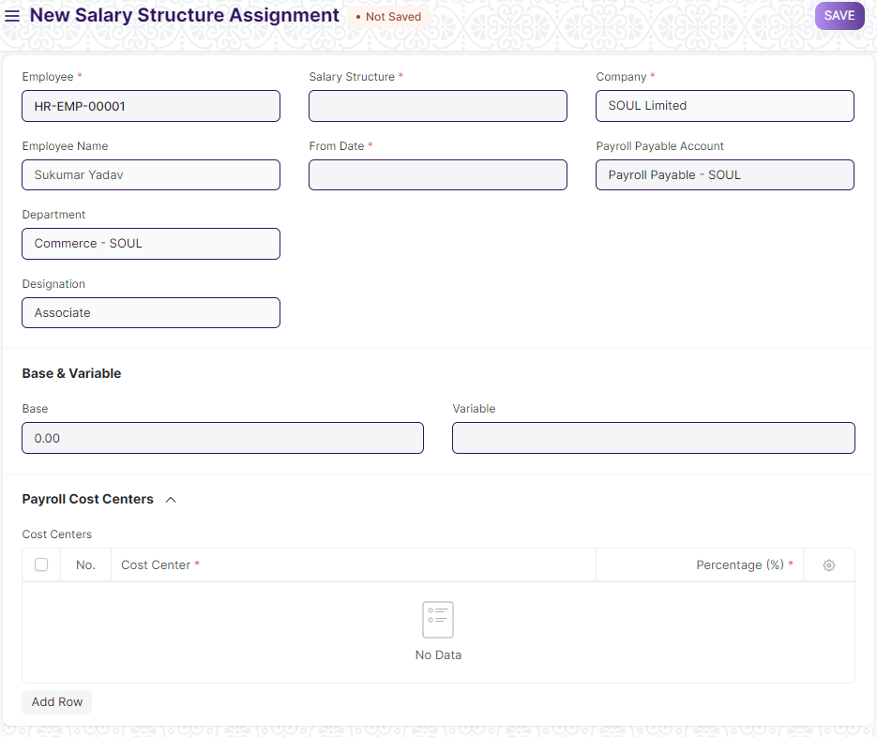

Figure 7 : Salary Structure Assignment

**Field List**

The following table describes the UI fields present in this screen :

|  |  |  |  |  |  |  |
| --- | --- | --- | --- | --- | --- | --- |
| **ID** | **Field Name** | **Field Type** | **Mandatory** | **Validation/ Action** | **Remarks** | **R = Rename**  **N= New**  **D= Delete** |
| 1. 1 | Employee | Link | Yes | Link to master screen “Employee” |  |  |
|  | Employee Name | Text |  | Employee name will be auto-populated on the basis of Employee selected. |  |  |
|  | Department | Link |  | Department will be auto-populated on the basis of Employee selected. |  |  |
|  | Designation | Link |  | Designation will be auto-populated on the basis of Employee selected. |  |  |
|  | Grade | Link |  | Grade will be auto-populated on the basis of Employee selected. |  |  |
|  | Salary Structure | Link | Yes | Link to the screen Salary Structure |  |  |
|  | From Date | Date | Yes |  |  |  |
|  | Income Tax Slab | Link |  | Link to the screen Income Tax Slab |  |  |
|  | Payroll Payable Account | Link |  | Link to the screen Account |  |  |
|  | Currency | Link | Yes |  |  |  |
|  | Base | Currency |  |  |  |  |
|  | Variable | Currency |  |  |  |  |
| 1. 13 | Taxable Earnings Till Date | Currency |  |  |  |  |
| 1. 14 | Tax Deducted Till Date | Currency |  |  |  |  |
| 1. 15 | Cost Centers | Table |  |  | This table is described  Below |  |
| Cost Centers | | | | | | |
| **ID** | **Field Name** | **Field Type** | **Mandatory** | **Validation/ Action** | **Remarks** | **R = Rename**  **N= New**  **D= Delete** |
| 1 | Cost Center | Link | Yes |  |  |  |
| 2 | Percentage | Number | Yes |  |  |  |

**Note:**

Alternate ways to create Salary Structure Assignment

1. User can also assign a Salary Structure to Employee(s) directly through the Salary Structure document. To assign the Salary Structure to a single employee, click on the 'Assign Salary Structure' button in the Salary Structure document.
2. If you want to bulk assign the Salary Structure to multiple employees, you can do so via the 'Assign to Employees' button.

|  |  |  |  |  |  |  |  |  |
| --- | --- | --- | --- | --- | --- | --- | --- | --- |
| **ID** | **Role** | **Read** | **Write** | **Create** | **Delete** | **Submit** | **Cancel** | **Amend** |
| 1 | Payroll Admin | Yes | Yes | Yes | Yes | Yes | Yes | Yes |
| 2 | Payroll User | Yes | Yes | Yes | No | Yes | No | No |
| 3 | HR Manager | Yes | Yes | Yes | No | Yes | No | No |
| 4 | Employee | No | No | No | No | NA | NA | NA |

### Salary Slip

**General Description**

The Following table describe overall information about this screen:

|  |  |  |
| --- | --- | --- |
| **Description** | | 1. A salary slip is a document issued to an employee. It contains a detailed description of the employee’s salary components and amounts. |
| **Navigation** | Home > Payroll> Payroll > Salary Slip | |
| **Pre-requisites** | The system should have records in the following screen:   1. Employee 2. Salary Structure 3. Salary Structure Assignment | |
| **Existing Screen Name** | Salary Slip | |
| **New Screen Name** | No change | |

**Screenshot**

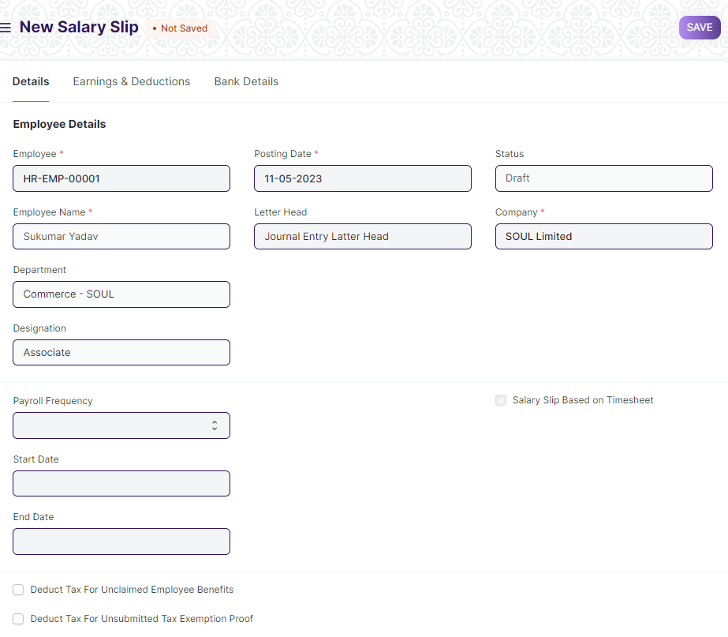

Figure 8 : Salary Slip Screen

**Field List**

The following table describes the UI fields present in this screen :

|  |  |  |  |  |  |  |  |  |  |  |  |  |  |
| --- | --- | --- | --- | --- | --- | --- | --- | --- | --- | --- | --- | --- | --- |
| ID | | Field Name | | **Field Type** | | Mandatory | Validation/  Action | | | Remarks | | **R = Rename**  **N= New**  **D= Delete** | |
| 1 | | Employee | | Link | | Yes | Link to the master screen “Employee” | | |  | |  | |
| 2 | | Employee Name | | Read Only | | Yes | Employee name will be auto-populated on the basis of Employee selected. | | |  | |  | |
| 3 | | Department | | Link | |  | Department will be auto-populated on the basis of Employee selected. | | |  | |  | |
| 4 | | Designation | | Link | |  | Designation will be auto-populated on the basis of Employee selected. | | |  | |  | |
| 5 | | Branch | | Link | |  | Branch will be auto-populated on the basis of Employee selected. | | |  | |  | |
| 6 | | Posting Date | | Date | | Yes |  | | |  | |  | |
| 7 | | Letter Head | | Link | |  |  | | |  | |  | |
| 8 | | Status | | Select | | Yes |  | | |  | |  | |
| 9 | | Company | | Link | | Yes | Link to the screen “company” | | |  | |  | |
| 10 | | Currency | | Link | | Yes |  | | |  | |  | |
| 11 | | Exchange Rate | | Float | |  |  | | |  | |  | |
| 12 | | Payroll Frequency | | Dropdown | |  | Options:   1. Monthly 2. Fortnightly 3. Weekly 4. Daily 5. Bimonthly | | |  | |  | |
| 13 | | Start Date | | Date | |  |  | | |  | |  | |
| 14 | | End Date | | Date | |  |  | | |  | |  | |
| 15 | | Salary Structure | | Link | | Yes | Link to the screen “Salary Structure” | | |  | |  | |
| 16 | | Payroll Entry | | Link | |  |  | | |  | |  | |
| 17 | | Mode Of Payment | | Dropdown | |  | Options:   1. Cash 2. Bank 3. Cheque | | |  | |  | |
| 18 | | Salary Slip Based on Timesheet | | Checkbox | |  |  | | |  | |  | |
| 19 | | Deduct Tax For Unclaimed Employee Benefits | | Checkbox | |  |  | | |  | |  | |
| 20 | | Deduct Tax For Unsubmitted Tax Exemption Proof | | Checkbox | |  |  | | |  | |  | |
| Tab Break(Payment Days) | | | | | | | | | | | | | |
| 21 | | Working Days | | Float | |  |  | | |  | |  | |
| 22 | | Unmarked days | | Float | |  |  | | |  | |  | |
| 23 | | Leave Without Pay | | Float | |  |  | | |  | |  | |
| 24 | | Absent Days | | Float | |  |  | | |  | |  | |
| 25 | | Payment Days | | Float | | Yes |  | | |  | |  | |
| Tab Break(Earning & Deduction) | | | | | | | | | | | | | |
| 26 | | Salary Slip Timesheet | | Table | |  |  | | | This table is described below. | |  | |
| 27 | | Total Working Hours | | Float | |  |  | | |  | |  | |
| 28 | | Hour Rate | | Currency | |  |  | | |  | |  | |
| 29 | | Hour Rate (Company Currency) | | Currency | |  |  | | |  | |  | |
| 30 | | Earnings | | Table | |  |  | | | This table is described below. | |  | |
| 31 | | Deductions | | Table | |  |  | | | This table is described below. | |  | |
| 32 | | Gross Pay | | Currency | |  |  | | |  | |  | |
| 33 | | Gross Pay (Company Currency) | | Currency | |  |  | | |  | |  | |
| 34 | | Gross Year To Date | | Currency | |  |  | | |  | |  | |
| 35 | | Gross Year To Date(Company Currency) | | Currency | |  |  | | |  | |  | |
| 36 | | Total Deduction | | Currency | |  |  | | |  | |  | |
| 37 | | Total Deduction (Company Currency) | | Currency | |  |  | | |  | |  | |
| 39 | | Total Principal Amount | | Currency | |  |  | | |  | |  | |
| 40 | | Total Interest Amount | | Currency | |  |  | | |  | |  | |
| 41 | | Total Loan Repayment | | Currency | |  |  | | |  | |  | |
| 42 | | Net Pay | | Currency | |  |  | | |  | |  | |
| 43 | | Net Pay (Company Currency) | | Currency | |  |  | | |  | |  | |
| 44 | | Year To Date | | Currency | |  |  | | |  | |  | |
| 45 | | Year To Date(Company Currency) | | Currency | |  |  | | |  | |  | |
| 46 | | Month To Date | | Currency | |  |  | | |  | |  | |
| 47 | | Month To Date(Company Currency) | | Currency | |  |  | | |  | |  | |
| 48 | | Rounded Total | | Currency | |  |  | | |  | |  | |
| 49 | | Rounded Total (Company Currency) | | Currency | |  |  | | |  | |  | |
| 50 | | Total in words | | Text | |  |  | | |  | |  | |
| 51 | | Total in words (Company Currency) | | Text | |  |  | | |  | |  | |
| 52 | | Journal Entry | | Link | |  |  | | |  | |  | |
| 53 | | Amended From | | Link | |  |  | | |  | |  | |
| 54 | | Bank Name | | Text | |  |  | | |  | |  | |
| 55 | | Bank Account No | | Text | |  |  | | |  | |  | |
| 56 | | Leave Details | | Table | |  |  | | | This table is described below. | |  | |
| Salary Slip Timesheet | | | | | | | | | | | | | |
| **ID** | | **Field Name** | | **Type** | | **Mandatory** | | | **Validation/ Action** | **Remarks** | | **R = Rename**  **N= New**  **D= Delete** | |
| 1 | | Time sheet | | Link | | Yes | | |  |  | |  | |
| 2 | | Working Hours | | Float | |  | | |  |  | |  | |
| Earnings | | | | | | | | | | | | | |
| **ID** | | **Field Name** | | **Field Type** | | **Mandatory** | | | **Validation/ Action** | **Remarks** | | **R = Rename**  **N= New**  **D= Delete** | |
| 1. 1 | | Component | | Link | | Yes | | | Link to master screen “Company” |  | |  | |
| 2 | | Abbr | | Text | |  | | |  |  | |  | |
| 3 | | Amount | | Currency | |  | | | Auto-fetched on the basis of selected “component” |  | |  | |
| 4 | | Year to date | | Currency | |  | | |  |  | |  | |
| 5 | | Additional Salary | | Link | |  | | | Link to screen “Additional Salary” |  | |  | |
| 6 | | Is Recurring addition | | Checkbox | |  | | | Auto-fetched on the basis of selected “component” |  | |  | |
| 7 | | Satistical Component | | Checkbox | |  | | | Auto-fetched on the basis of selected “component” |  | |  | |
| 8 | | Depends on Payment Days | | Checkbox | |  | | | Auto-fetched on the basis of selected “component” |  | |  | |
| 9 | | Exempted from Income Tax | | Checkbox | |  | | | Auto-fetched on the basis of selected “component” |  | |  | |
| 10 | | Is Tax Applicable | | Checkbox | |  | | | Auto-fetched on the basis of selected “component” |  | |  | |
| 11 | | Is Flexible Benefit | | Checkbox | |  | | | Auto-fetched on the basis of selected “component” |  | |  | |
| 12 | | Variable based on Taxable salary | | Checkbox | |  | | | Auto-fetched on the basis of selected “component” |  | |  | |
| 13 | | Do not include in the total | | Checkbox | |  | | | Auto-fetched on the basis of selected “component” |  | |  | |
| 14 | | Deduct Full Tax on Selected Payroll Date. | | Checkbox | |  | | | Auto-fetched on the basis of selected “component” |  | |  | |
| 15 | | Condition | | Code | |  | | |  |  | |  | |
| 16 | | Amount based on formula | | Checkbox | |  | | |  |  | |  | |
| 17 | | Default Amount | | Currency | |  | | |  |  | |  | |
| 18 | | Additional Amount | | Currency | |  | | |  |  | |  | |
| 19 | | Tax on flexible benefit | | Currency | |  | | |  |  | |  | |
| 20 | | Tax on additional salary | | Currency | |  | | |  |  | |  | |
| Deduction | | | | | | | | | | | | | |
| **ID** | | **Field Name** | | **Type** | | **Mandatory** | | | **Validation/ Action** | **Remarks** | | **R = Rename**  **N= New**  **D= Delete** | |
| 1 | | Component | | Link | | Yes | | | Link to master screen “Company” |  | |  | |
| 2 | | Abbr | | Text | |  | | |  |  | |  | |
| 3 | | Amount | | Currency | |  | | | Auto-fetched on the basis of selected “component” |  | |  | |
| 4 | | Year to date | | Currency | |  | | |  |  | |  | |
| 5 | | Additional Salary | | Link | |  | | | Link to screen “Additional Salary” |  | |  | |
| 6 | | Is Recurring addition | | Checkbox | |  | | | Auto-fetched on the basis of selected “component” |  | |  | |
| 7 | | Satistical Component | | Checkbox | |  | | | Auto-fetched on the basis of selected “component” |  | |  | |
| 8 | | Depends on Payment Days | | Checkbox | |  | | | Auto-fetched on the basis of selected “component” |  | |  | |
| 9 | | Exempted from Income Tax | | Checkbox | |  | | | Auto-fetched on the basis of selected “component” |  | |  | |
| 10 | | Is Tax Applicable | | Checkbox | |  | | | Auto-fetched on the basis of selected “component” |  | |  | |
| 11 | | Is Flexible Benefit | | Checkbox | |  | | | Auto-fetched on the basis of selected “component” |  | |  | |
| 12 | | Variable based on Taxable salary | | Checkbox | |  | | | Auto-fetched on the basis of selected “component” |  | |  | |
| 13 | | Do not include in the total | | Checkbox | |  | | | Auto-fetched on the basis of selected “component” |  | |  | |
| 14 | | Deduct Full Tax on Selected Payroll Date. | | Checkbox | |  | | | Auto-fetched on the basis of selected “component” |  | |  | |
| 15 | | Condition | | Code | |  | | |  |  | |  | |
| 16 | | Amount based on formula | | Checkbox | |  | | |  |  | |  | |
| 17 | | Default Amount | | Currency | |  | | |  |  | |  | |
| 18 | | Additional Amount | | Currency | |  | | |  |  | |  | |
| 19 | | Tax on flexible benefit | | Currency | |  | | |  |  | |  | |
| 20 | | Tax on additional salary | | Currency | |  | | |  |  | |  | |
| Leave Details | | | | | | | | | | | | | |
| **ID** | | **Field Name** | | **Field Type** | | **Mandatory** | | | **Validation/ Action** | **Remarks** | | **R = Rename**  **N= New**  **D= Delete** | |
| 1 | | Leave Type | | Link | |  | | | Link to screen “Leave Type” |  | |  | |
| 2 | | Total Allocated Leave | | Float | |  | | |  |  | |  | |
| 3 | | Expired Leaves(s) | | Float | |  | | |  |  | |  | |
| 4 | | Used Leave(s) | | Float | |  | | |  |  | |  | |
| 5 | | Leave(s) Pending | | Float | |  | | |  |  | |  | |
| 6 | | Available Leave(s) | | Float | |  | | |  |  | |  | |

**Note:**

**Salary Slip based on Attendance/Leave**

Users can create Salary Slip based on Attendance or leave. The Working days will calculated on basis of leave/Attendance, depending on the field Calculate Payroll Working Days Based On in [HR Settings](https://frappehr.com/docs/v14/user/manual/en/human-resources/hr-settings). If Payroll is based on **Attendance** then**, the Leave without pay will be considered as absent and half-day will be considered as half-day absent.**

**Salary Slip based on Timesheet**

For creating Salary Slip based on timesheet you need to create Salary Structure for Timesheet.ERP also provides an option to create Salary slip based on working hours based on [Timesheet](https://frappehr.com/docs/v14/user/manual/en/projects/timesheets). You can create Salary Slip after submitting the Timesheet by clicking directly on Create Salary Slip button on the top right.

**Users: Roles & Permission**

The following table describes the users and their roles and permissions for the screens :

|  |  |  |  |  |  |  |  |  |
| --- | --- | --- | --- | --- | --- | --- | --- | --- |
| **ID** | **Role** | **Read** | **Write** | **Create** | **Delete** | **Submit** | **Cancel** | **Amend** |
| 1 | Payroll Admin | Yes | Yes | Yes | Yes | Yes | Yes | Yes |
| 2 | Payroll User | Yes | Yes | Yes | No | Yes | No | No |
| 3 | HR Manager | Yes | No | No | No | Yes | No | No |
| 4 | Employee | No | No | No | No | No | No | No |

### Payroll Entry

**General Description**

The Following table describe overall information about this screen:

|  |  |
| --- | --- |
| Description | 1. Payroll is the sum of all compensation a business must pay to its employees for a set of time or on a given date. 2. In ERP,Payroll Entry enables bulk processing of payroll for employees. |
| **Navigation** | Home > Payroll> Payroll > Payroll Entry |
| **Pre-requisites** | The system should have records in the following screen:   1. Salary Structure Assignment |
| **Existing Screen Name** | Payroll Entry |
| **New Screen Name** | No change |

**Screenshot**

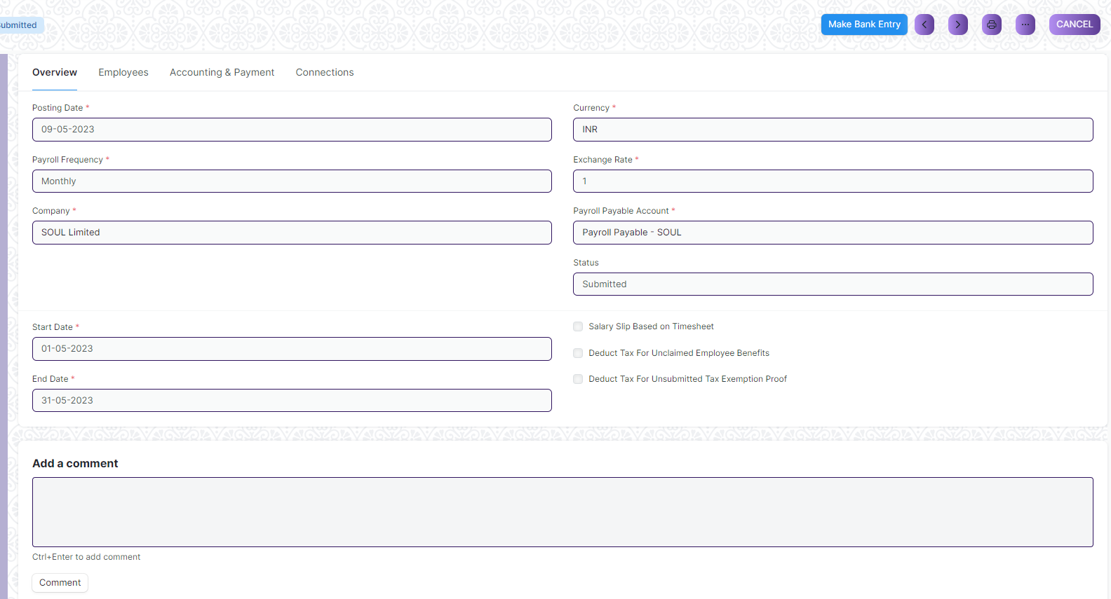

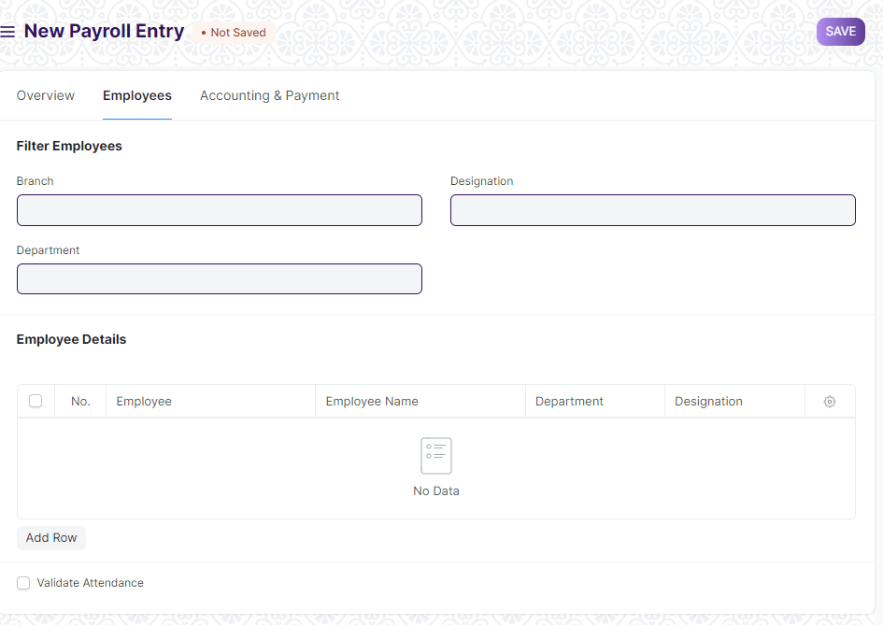

Figure 9 : Payroll Entry Screen

**Field List**

The following table describes the UI fields present in this screen :

|  |  |  |  |  |  |  |  |  |  |  |  |  |  |  |
| --- | --- | --- | --- | --- | --- | --- | --- | --- | --- | --- | --- | --- | --- | --- |
| ID | | Field Name | | **Field Type** | | | Mandatory | | **Validation/ Action** | | **Remarks** | | **R = Rename**  **N= New**  **D= Delete** | |
| 1 | | Posting Date | | Date | | | Yes | |  | |  | |  | |
| 2 | | Payroll Frequency | | Dropdown | | | Yes | | Options:  Monthly  Fortnightly  Weekly  Daily  Bimonthly | |  | |  | |
| 3 | | Company | | Link | | | Yes | | Linked to the master screen “Company” | |  | |  | |
| 4 | | Currency | | Link | | | Yes | |  | |  | |  | |
| 5 | | Exchange Rate | | Float | | | Yes | |  | |  | |  | |
| 6 | | Payroll Payable Account | | Link | | | Yes | | Link to the screen “Account” | |  | |  | |
| 7 | | Status | | Dropdown | | |  | | Options:  Draft  Submitted  Cancelled  Queued  Failed | |  | |  | |
| 8 | | Start Date | | Date | | | Yes | |  | |  | |  | |
| 9 | | End Date | | Date | | | Yes | |  | |  | |  | |
| 10 | | Salary Slip Based on Timesheet | | Checkbox | | |  | | If checkbox is checked,salary slip will be generated on the basis of timesheet. | |  | |  | |
| 11 | | Deduct Tax For Unclaimed Employee Benefits | | Checkbox | | |  | |  | |  | |  | |
| 12 | | Deduct Tax For Unsubmitted Tax Exemption Proof | | Checkbox | | |  | |  | |  | |  | |
| 13 | | Branch | | Link | | |  | | Link to master screen “Branch” | |  | |  | |
| 14 | | Department | | Link | | |  | | Link to master screen “Department” | |  | |  | |
| 15 | | Designation | | Link | | |  | | Link to master screen “Designation” | |  | |  | |
| 16 | | Number Of Employees | | Number | | |  | |  | |  | |  | |
| 17 | | Employee Detail | | Table | | |  | |  | | This table is described below | |  | |
| 18 | | Validate Attendance | | Checkbox | | |  | | This checkbox is checked to validate the employees attendance. | |  | |  | |
| 19 | | Attendance Validation Proof | | Attachment | | |  | |  | |  | | N | |
| 19 | | Address | | Link | | |  | |  | |  | |  | |
| 20 | | Article | | Link | | |  | |  | |  | |  | |
| 21 | | Cost Center | | Link | | | Yes | |  | |  | |  | |
| 22 | | About Us Team Member | | Link | | |  | |  | | Optional field | |  | |
| 23 | | Project | | Link | | |  | |  | | Optional field | |  | |
| 24 | | Payment Account | | Link | | |  | |  | |  | |  | |
| 25 | | Bank Account | | Link | | |  | |  | |  | |  | |
| 26 | | Salary Slips Created | | Checkbox | | |  | |  | |  | |  | |
| 27 | | Salary Slips Submitted | | Checkbox | | |  | |  | |  | |  | |
| 28 | | Error Message | | Small Text | | |  | |  | |  | |  | |
|  | | **Get Employees** | | Button | | |  | | Once the information is saved, click on the Get Employees button to get a list of Employees for which the Salary Slips will be created based on the selected criteria. | |  | |  | |
|  | | **Create Salary Slip** | | Button | | |  | | Once the list of Employees is fetched, click on the Create Salary Slips button to generate Salary Slips. | |  | |  | |
|  | | **Submit Salary Slip** | |  | | |  | | After verifying the Salary Slips, you can Submit them all together by clicking on the Submit Salary Slip button. | |  | |  | |
| Employee Details | | | | | | | | | | | | |
| **ID** | | **Field Name** | | **Field Type** | **Mandatory** | | **Validation/ Action** | | **Remarks** | | **R = Rename**  **N= New**  **D= Delete** | |
| 1 | | Employee | | Link |  | |  | |  | |  | |
| 2 | | Employee Name | | Text |  | |  | |  | |  | |
| 3 | | Department | | Link |  | |  | |  | |  | |
| 4 | | Designation | | Text |  | |  | |  | |  | |

**Note:**

1. If user want to change the attendance after validation process,user can cancel and amend the Employee’s attendance via Employee Attendance Form**.**
2. Once the Salary Slip is submitted,this will book the default Payroll Payable account against Expenses head to record the accrual of salary to employees.
3. The salary payment entry is a Journal Entry that debits the total of the Earnings type salary component and credits the total of Deductions type salary component of all Employees to the default account set at Salary Component level for each component.

To generate your salary payment voucher from Payroll Entry, click on the Make Bank Entry button.

**Users: Roles & Permission**

The following table describes the users and their roles and permissions for the screens :

|  |  |  |  |  |  |  |  |  |
| --- | --- | --- | --- | --- | --- | --- | --- | --- |
| **ID** | **Role** | **Read** | **Write** | **Create** | **Delete** | **Submit** | **Cancel** | **Amend** |
| 1 | Payroll Admin | Yes | Yes | Yes | Yes | Yes | Yes | Yes |
| 2 | Payroll User | Yes | Yes | Yes | No | Yes | No | No |
| 3 | HR Manager | Yes | Yes | Yes | No | Yes | No | No |
| 4 | Employee | No | No | No | No | No | No | No |

### Expense Claim Type

**General Description**

The Following table describe overall information about this screen:

|  |  |
| --- | --- |
| Description | 1. It defines the different kind of expenses for which claim can be made like Internet Expenses,Medical,calls and so on. |
| **Navigation** | Home > Payroll> Claims>Expense Claim Type |
| **Pre-requisites** | The system should have records in the following screen:   1. Company |
| **Existing Screen Name** | Expense Claim Type |
| **New Screen Name** | No change |

**Screenshot**

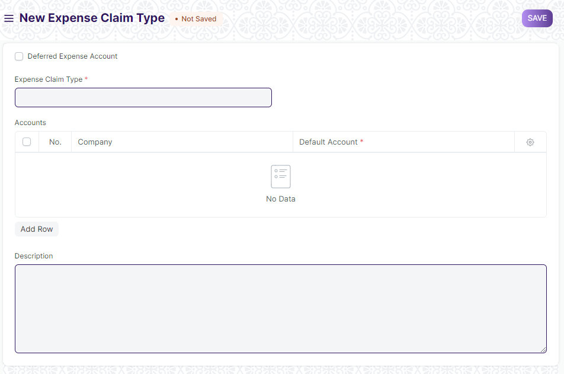

Figure 10: Expense Claim Type

**Field List**

The following table describes the UI fields present in this screen :

|  |  |  |  |  |  |  |  |  |  |  |  |  |  |  |
| --- | --- | --- | --- | --- | --- | --- | --- | --- | --- | --- | --- | --- | --- | --- |
| ID | | Field Name | | **Field Type** | | | Mandatory | | **Validation/ Action** | | **Remarks** | | **R = Rename**  **N= New**  **D= Delete** | |
| 1 | | Deferred Expense Account | | Checkbox | | |  | |  | |  | |  | |
| 2 | | Expense Claim Type | | Text | | | Yes | |  | |  | |  | |
| 3 | | Accounts | | Table | | |  | |  | | This table is described below | |  | |
| 4 | | Description | | Small Text | | |  | |  | |  | |  | |
| Accounts | | | | | | | | | | | | |
| **ID** | | **Field Name** | | **Field Type** | **Mandatory** | | **Validation/ Action** | | **Remarks** | | **R = Rename**  **N= New**  **D= Delete** | |
| 1 | | Company | | Link |  | | Link to the master screen “Company” | |  | |  | |
| 2 | | Default Account | | Link |  | |  | |  | |  | |

**Users: Roles & Permission**

The following table describes the users and their roles and permissions for the screens :

|  |  |  |  |  |  |  |  |  |
| --- | --- | --- | --- | --- | --- | --- | --- | --- |
| **ID** | **Role** | **Read** | **Write** | **Create** | **Delete** | **Submit** | **Cancel** | **Amend** |
| 1 | Payroll Admin | Yes | Yes | Yes | Yes | NA | NA | NA |
| 2 | Payroll User | Yes | Yes | Yes | No | NA | NA | NA |
| 3 | HR Manager | Yes | No | No | No | NA | NA | NA |
| 4 | Employee | Yes | No | No | No | NA | NA | NA |

### Expense Claim

**General Description**

The Following table describe overall information about this screen:

|  |  |
| --- | --- |
| Description | 1. Expense Claim is made when employees make expenses out of their pocket on behalf of the company. |
| **Navigation** | Home > Payroll> Claims>Expense Claim |
| **Pre-requisites** | The system should have records in the following screen:   1. Employee 2. Chart of Accounts |
| **Existing Screen Name** | Expense Claim |
| **New Screen Name** | No change |

**Screenshot**

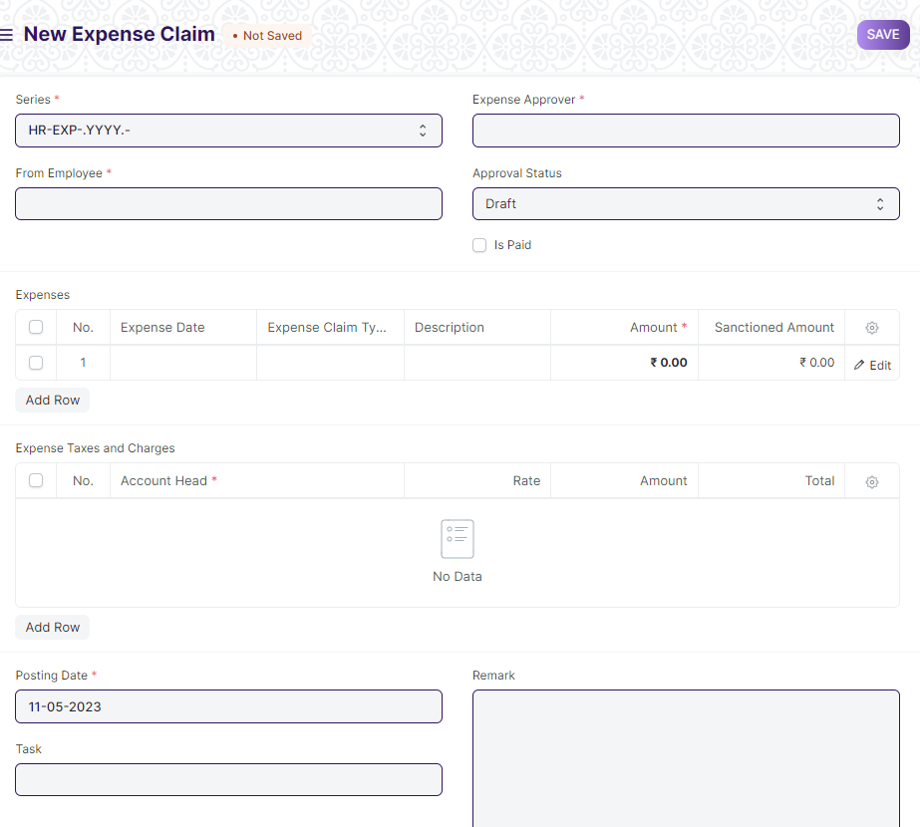

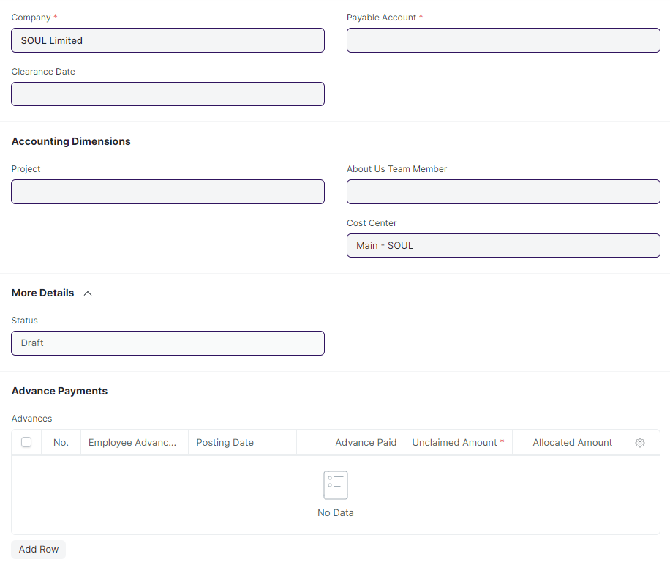

Figure 11 : Expense Claim Screen

**Field List**

The following table describes the UI fields present in this screen :

|  |  |  |  |  |  |  |  |  |  |  |  |  |
| --- | --- | --- | --- | --- | --- | --- | --- | --- | --- | --- | --- | --- |
| ID | Field Name | | **Field Type** | | | Mandatory | | **Validation/ Action** | **Remarks** | | | **R = Rename**  **N= New**  **D= Delete** |
| 1 | Series | | Dropdown | | | Yes | |  |  | | |  |
| 2 | From Employee | | Link | | | Yes | |  |  | | |  |
| 3 | Employee Name | | Text | | |  | |  |  | | |  |
| 4 | Department | | Link | | |  | |  |  | | |  |
| 5 | Expense Approver | | Link | | |  | |  |  | | |  |
| 6 | Approval Status | | Dropdown | | |  | | Options:  Draft  Approved  Rejected |  | | |  |
| 7 | Delivery Trip | | Link | | |  | |  |  | | |  |
| 8 | Is Paid | | Checkbox | | |  | |  |  | | |  |
| 9 | Expenses | | Table | | | Yes | |  | This table is described below. | | |  |
| 10 | Expense Taxes and Charges | | Table | | |  | |  | This table is described below. | | |  |
| 11 | Total Sanctioned Amount | | Currency | | |  | |  |  | | |  |
| 12 | Total Taxes and Charges | | Currency | | |  | |  |  | | |  |
| 13 | Total Advance Amount | | Currency | | |  | |  |  | | |  |
| 14 | Grand Total | | Currency | | |  | |  |  | | |  |
| 15 | Total Claimed Amount | | Currency | | |  | |  |  | | |  |
| 16 | Total Amount Reimbursed | | Currency | | |  | |  |  | | |  |
| 17 | Posting Date | | Date | | | Yes | |  |  | | |  |
| 18 | Vehicle Log | | Link | | |  | |  |  | | |  |
| 19 | Task | | Link | | |  | |  |  | | |  |
| 20 | Remark | | Small Text | | |  | |  |  | | |  |
| 21 | Title | | Text | | |  | |  |  | | |  |
| 22 | Employees Email Id | | Text | | |  | |  |  | | |  |
| 23 | Company | | Link | | | Yes | |  |  | | |  |
| 24 | Mode of Payment | | Link | | |  | | Link to screen “Mode of Payment” |  | | |  |
| 25 | Clearance Date | | Date | | |  | |  |  | | |  |
| 26 | Payable Account | | Link | | | Yes | |  |  | | |  |
| 27 | Address | | Link | | |  | |  |  | | |  |
| 28 | Article | | Link | | |  | |  |  | | |  |
| 29 | Project | | Link | | |  | |  | Optional field | | |  |
| 30 | Branch | | Link | | |  | |  | Optional field | | |  |
| 31 | About Us Team Member | | Link | | |  | |  | Optional field | | |  |
| 32 | Cost Center | | Link | | |  | |  |  | | |  |
| 33 | Status | | Dropdown | | |  | | Options:  Draft  Paid  Unpaid  Rejected  Submitted  Cancelled |  | | |  |
| 34 | Advances | | Table | | |  | |  | This table is described below | | |  |
|  | **Payment Entry** | |  | | |  | | Once the Expense Claim is Approved,Payment Entry button will appear and user can create payment entry after clicking on it. |  | | |  |
| Expenses | | | | | | | | | | | | | | |
| **ID** | | | **Field Name** | | **Field Type** | **Mandatory** | | **Validation/ Action** | | | **Remarks** | **R = Rename**  **N= New**  **D= Delete** | | |
| 1 | | | Expense Date | | Date |  | |  | | |  |  | | |
| 2 | | | Expense Claim Type | | Link | Yes | |  | | |  |  | | |
| 3 | | | Default Account | | Link |  | |  | | |  |  | | |
| 4 | | | Description | | Text Editor |  | |  | | |  |  | | |
| 5 | | | Amount | | Currency | Yes | |  | | |  |  | | |
| 6 | | | Sanctioned Amount | | Currency |  | |  | | |  |  | | |
| 7 | | | Cost Center | | Link |  | |  | | |  |  | | |
| Expenses Taxes and Charges | | | | | | | | | | | | | | |
| **ID** | | | **Field Name** | | **Field Type** | **Mandatory** | | **Validation/ Action** | | | **Remarks** | **R = Rename**  **N= New**  **D= Delete** | | |
| 1 | | | Account Head | | Date | Yes | |  | | |  |  | | |
| 2 | | | Rate | | Link |  | |  | | |  |  | | |
| 3 | | | Description | | Link | Yes | |  | | |  |  | | |
| 4 | | | Amount | | Text Editor |  | |  | | |  |  | | |
| 5 | | | Total | | Currency |  | |  | | |  |  | | |
| 6 | | | Cost Center | | Currency |  | |  | | |  |  | | |
| Expense Claim Advance | | | | | | | | | | | | | | |
| **ID** | | | **Field Name** | | **Field Type** | **Mandatory** | | **Validation/ Action** | | | **Remarks** | **R = Rename**  **N= New**  **D= Delete** | | |
| 1 | | | Employee Advance | | Link | Yes | |  | | |  |  | | |
| 2 | | | Posting Date | | Date |  | |  | | |  |  | | |
| 3 | | | Advance Amount | | Currency |  | |  | | |  |  | | |
| 4 | | | Unclaimed Amount | | Currency | Yes | |  | | |  |  | | |
| 5 | | | Allocated Amount | | Currency |  | |  | | |  |  | | |
| 6 | | | Advance Account | | Link |  | |  | | |  |  | | |

**Workflow:**

1. Approver for the Expense Claim is selected by an Employee himself. Employee can choose from the list of users who are configured as Expense Approvers for their [Department](https://frappehr.com/docs/v14/user/manual/en/human-resources/department).
2. When a new Expense Claim is created, if the selected expense Approver does not have access to it, the document is shared with the Approver with "submit" permission.
3. After saving Expense Claim, Employee should [Assign document to Approver](https://frappehr.com/docs/v14/user/manual/en/using-erpnext/assignment). On assignment, approving user will also receive email notification. To automate email notification, you can also setup Email Alert
4. Expense Claim Approver can update the “Sanctioned Amounts” against Claimed Amount of an Employee. If submitting, Approval Status should be submitted to Approved or Rejected. If Approved, then Expense Claim gets submitted. If rejected, then Expense Approver's comments can be added in the Comments section explaining why the claim was approved or rejected.

**Payment for Expense Claim**

To make payment against the expense claim, user has to click on Create > Payment

**Users: Roles & Permission**

The following table describes the users and their roles and permissions for the screens :

|  |  |  |  |  |  |  |  |  |
| --- | --- | --- | --- | --- | --- | --- | --- | --- |
| **ID** | **Role** | **Read** | **Write** | **Create** | **Delete** | **Submit** | **Cancel** | **Amend** |
| 1 | Payroll Admin | Yes | Yes | Yes | Yes | Yes | Yes | Yes |
| 2 | Payroll User | Yes | Yes | Yes | No | Yes | No | No |
| 3 | HR Manager | Yes | Yes | Yes | No | Yes | No | No |
| 4 | Employee | Yes | Yes | Yes | No | No | No | No |

### Employee Advance

**General Description**

The Following table describe overall information about this screen:

|  |  |
| --- | --- |
| Description | 1. Sometimes employees go outside for company's work and company pays some amount for their expenses in advance. This is when the employee can create an Employee Advance form where details such as the Purpose of Expense and Expense Amount can be recorded. |
| **Navigation** | Home > Payroll> Claims>Employee Advance |
| **Pre-requisites** | The system should have records in the following screen:   1. Employee 2. Chart of Accounts |
| **Existing Screen Name** | Employee Advance |
| **New Screen Name** | No change |

**Screenshot**

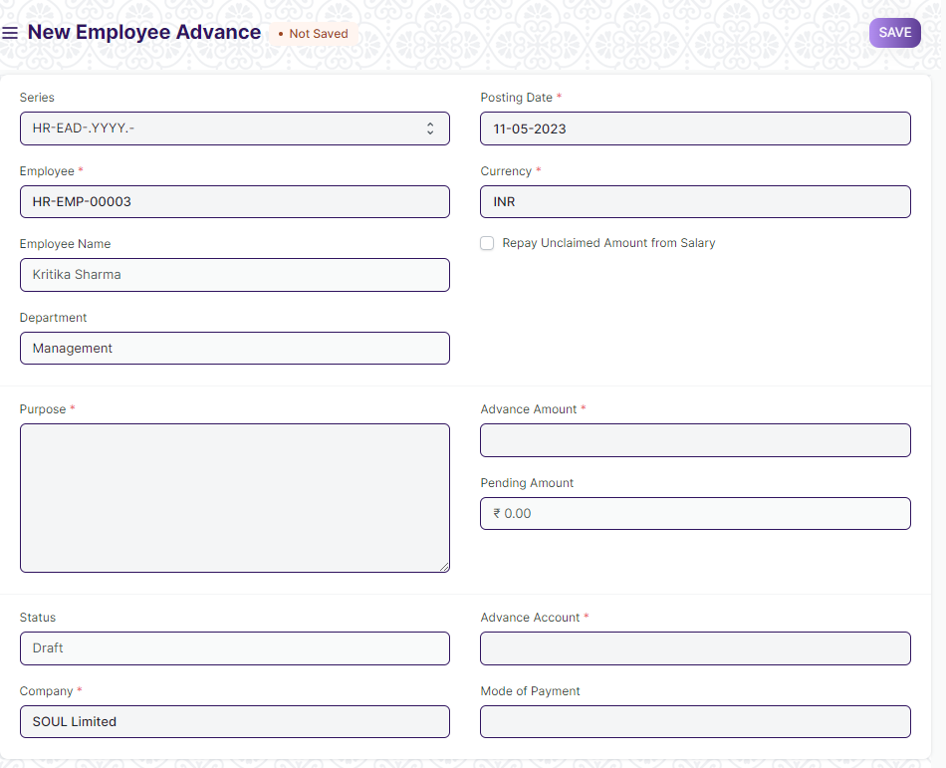

Figure 12 : Employee Advance Screen

**Field List**

The following table describes the UI fields present in this screen :

|  |  |  |  |  |  |  |
| --- | --- | --- | --- | --- | --- | --- |
| ID | Field Name | **Field Type** | Mandatory | **Validation/ Action** | **Remarks** | **R = Rename**  **N= New**  **D= Delete** |
| 1 | Series | Dropdown | Yes | HR-EAD-YYYY |  |  |
| 2 | From Employee | Link | Yes | Linked to master screen “Employee” |  |  |
| 3 | Employee Name | Text |  | Employee Name will be fetched on the basis on Employee selected. |  |  |
| 4 | Department | Link |  | Department will be fetched on the basis on Employee selected. |  |  |
| 5 | Posting Date | Date | Yes |  |  |  |
| 6 | Currency | Link | Yes | Link to screen “Currency” |  |  |
| 7 | Exchange Rate | Float | Yes |  |  |  |
| 8 | Purpose | Small Text | Yes |  |  |  |
| 9 | Repay Unclaimed Amount from Salary | Chekbox |  |  |  |  |
| 10 | Advance Amount | Currency | Yes |  |  |  |
| 11 | Paid Amount | Currency |  |  |  |  |
| 12 | Pending Amount | Currency |  |  |  |  |
| 13 | Claimed Amount | Currency |  |  |  |  |
| 14 | Returned Amount | Currency |  |  |  |  |
| 15 | Status | Dropdown |  | Options:  Draft  Paid  Unpaid  Claimed  Returned  Partly Claimed and Returned | The statuses is explained below |  |
| 16 | Company | Link | Yes |  |  |  |
| 17 | Advance Account | Link | Yes |  |  |  |
| 18 | Mode of Payment | Link |  |  |  |  |
|  | **Payment Entry** | Button |  | After submission of Employee Advance record, accounts user will be able to create a [Payment Entry](https://frappehr.com/docs/v14/user/manual/en/accounts/payment-entry) using the 'Create' button. |  |  |

**Note:**

**Statuses:**

These are the statuses that are automatically set for Employee Advance.

* **Draft**: A draft is saved but yet to be submitted.
* **Paid**: Advance has been Paid to the employee and a [Payment Entry](https://frappehr.com/docs/v14/user/manual/en/accounts/payment-entry) has been submitted.
* **Unpaid**: Advance is not paid out to the employee yet. A Payment Entry is not created against the advance.
* **Claimed**: After the advance is paid, the employee has claimed the entire Paid Amount via [Expense Claim](https://frappehr.com/docs/v14/user/manual/en/human-resources/expense-claim).
* **Returned**: After the advance is paid, the employee has returned the entire Paid Amount and a return entry is submitted via Payment Entry/Journal Entry.
* **Partly Claimed and Returned**: After the advance is paid, the employee has partially claimed the Paid Amount via Expense Claim and returned the remaining amount via a submitted Payment Entry/Journal Entry.
* **Cancelled**: The Advance is Cancelled due to any reason.

**Workflow:**

1. Once the Employee Advance is created by the Employee, the Expense Approver can submit the advance record after verification. After Employee Advance gets submitted, the accountant releases the payment and makes the Payment Entry.

**Adjust Advances on Expense Claim**

Later when the employee claims the expense, an advance record can be fetched in the [Expense Claim](https://frappehr.com/docs/v14/user/manual/en/human-resources/expense-claim) and linked to the claim record.

**Employee Advance is Paid**

On submission of the Payment Entry/Journal Entry, the paid amount and status will be updated in Employee Advance record.

**Return Amount**

* When advance is paid to an Employee, there are three situations:

1. The amount may be unused
2. All of it may be used
3. Some part may be used

Create the Employee Advance, create a payment entry to indicate that the amount is paid.

* If amount is unused, click on the Return button to return the paid Advance amount
* If all of the advance is used, it will reflect in the Claimed Amount field
* If only some amount is claimed and rest is returned, the returned amount will be shown in the 'Returned Amount' field.

**Users: Roles & Permission**

The following table describes the users and their roles and permissions for the screens :

|  |  |  |  |  |  |  |  |  |
| --- | --- | --- | --- | --- | --- | --- | --- | --- |
| **ID** | **Role** | **Read** | **Write** | **Create** | **Delete** | **Submit** | **Cancel** | **Amend** |
| 1 | Payroll Admin | Yes | Yes | Yes | Yes | Yes | Yes | Yes |
| 2 | Payroll User | Yes | Yes | Yes | No | Yes | No | No |
| 3 | HR Manager | Yes | Yes | Yes | No | Yes | No | No |
| 4 | Employee | Yes | Yes | No | No | No | No | No |

### Journal Entry

**General Description**

The Following table describe overall information about this screen:

|  |  |
| --- | --- |
| Description | 1. A Journal Entry is an entry made in the general ledger and it indicates the affected accounts. |
| **Navigation** | Home > Payroll> Accounting> Journal Entry |
| **Pre-requisites** | The system should have records in the following screen   1. Company 2. Finance Book 3. Journal Entry Template 4. Account 5. Party Type 6. Party 7. Letter Head 8. Print Heading 9. Mode of Payment |
| **Existing Screen Name** | Journal Entry |
| **New Screen Name** | No change |

**Screenshot**

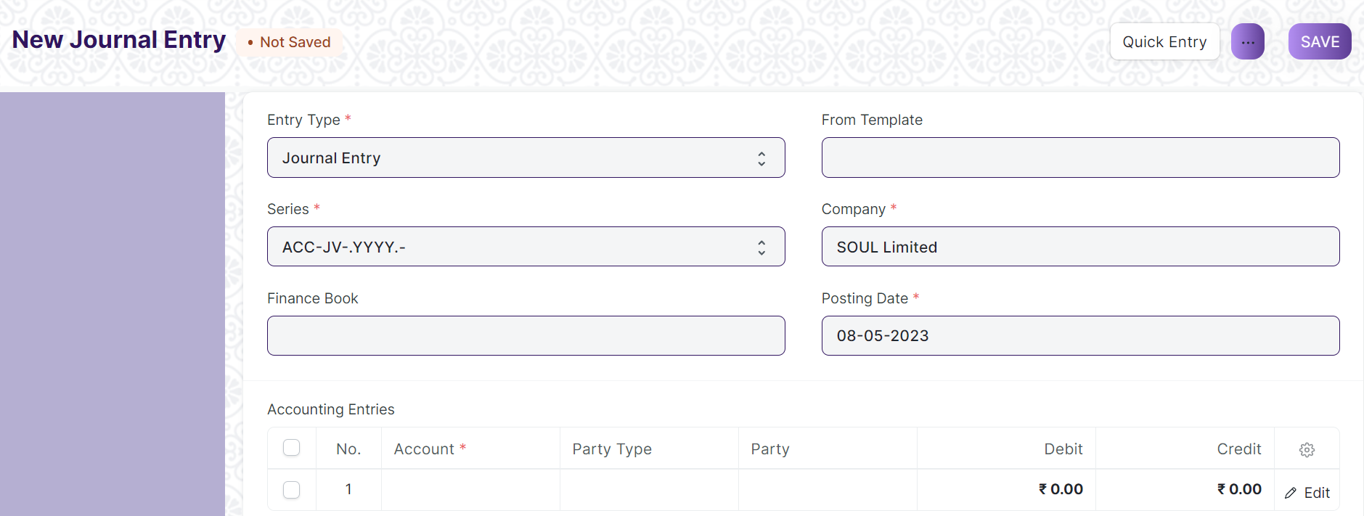 Figure 13 : Journal Entry Screen

**Field List**

The following table describes the UI fields present in this screen :

|  |  |  |  |  |  |  |  |
| --- | --- | --- | --- | --- | --- | --- | --- |
| **ID** | **Field Name** | | **Field Type** | **Mandatory** | **Validation/ Action** | **Remarks** | **R = Rename**  **N= New**  **D= Delete** |
|  | Title | | Text |  |  |  |  |
|  | Entry Type | | Dropdown | Yes | Options:  Journal Entry  Inter Company Journal Entry  Bank Entry  Cash Entry  Credit Card Entry  Debit Note  Credit Note  Contra Entry  Excise Entry  Write Off Entry  Opening Entry  Depreciation Entry  Exchange Rate Revaluation  Deferred Revenue  Deferred Expense |  |  |
|  | Finance Book | | Link |  | Link Fields to Finance Book Screen |  |  |
|  | Process Deferred Accounting | | Link |  | Link Fields to Process Deferred Accounting Screen |  |  |
|  | Reversal Of | | Link |  | Link Fields to Journal Entry Screen |  |  |
|  | Tax Withholding Category | | Link |  | Link Fields to Tax Withholding Category Screen |  |  |
|  | From Template | | Link |  | Link Fields to Journal Entry Template Screen |  |  |
|  | Company | | Link | Yes | Link Fields to Company Screen |  |  |
|  | Posting Date | | Date | Yes |  |  |  |
|  | Apply Tax Withholding Amount | | Checkbox |  |  |  |  |
|  | Accounting Entries | | Table | Yes | Journal Entry Account |  |  |
|  | Reference Number | | Text |  |  |  |  |
|  | Reference Date | | Date |  |  |  |  |
|  | User Remark | | Small Text |  |  |  |  |
|  | Total Debit | | Currency |  |  |  |  |
|  | Total Credit | | Currency |  |  |  |  |
|  | Difference (Dr - Cr) | | Currency |  |  |  |  |
|  | Make Difference Entry | | Button |  |  |  |  |
|  | Multi Currency | | Check box |  |  |  |  |
|  | Total Amount Currency | | Link |  | Link Fields to Currency Screen |  |  |
|  | Total Amount | | Currency |  |  |  |  |
|  | Total Amount in Words | | Text |  |  |  |  |
|  | Clearance Date | | Date |  |  |  |  |
|  | Remark | | Small Text |  |  |  |  |
|  | Paid Loan | | Text |  |  |  |  |
|  | Bill No | | Text |  |  |  |  |
|  | Bill Date | | Date |  |  |  |  |
|  | Due Date | | Date |  |  |  |  |
|  | Get Outstanding Invoices | | Button |  |  |  |  |
|  | Pay To / Recd From | | Text |  |  |  |  |
|  | Letter Head | | Link |  | Link Fields to Letter Head Screen |  |  |
|  | Print Heading | | Link |  | Link Fields to Print Heading Screen |  |  |
|  | Mode of Payment | | Link |  | Link Fields to Mode of Payment Screen |  |  |
|  | Payment Order | | Link |  | Link Fields to Payment Order Screen |  |  |
|  | Is Opening | | Dropdown |  | Options  No  Yes |  |  |
|  | Stock Entry | | Link Fields |  | Link Fields to Stock Entry Screen |  |  |
|  | Auto Repeat | | Link Fields |  | Link Fields to Auto Repeat Screen |  |  |
|  | Quick Entry | | | | Action Button | On Click a Popup will open and the user need to enter the Credit account, Debit account, date, etc. |  |
|  | Amount | Text | | Yes |  | On Click the Quick Entry Button, this field will visible inside a popup. |  |
|  | Debit Account | Link | | Yes | Link Field to Account Screen | On Click the Quick Entry Button, this field will visible inside a popup. |  |
|  | Credit Account | Link | | Yes |  | On Click the Quick Entry Button, this field will visible inside a popup. |  |
|  | Date | Date | | Yes |  | On Click the Quick Entry Button, this field will visible inside a popup. |  |
|  | User Remark | | Long Text |  |  | On Click the Quick Entry Button, this field will visible inside a popup. |  |
|  | Series | | Naming Series | Yes | Create the unique naming series for the records. | On Click the Quick Entry Button, this field will visible inside a popup. |  |
|  | View --> Ledger | | | |  | On click the General Ledger Screen will open in report view. |  |
|  | Action --> Reverse Journal Entry | | | |  | It Creates another new record when user can do reverse journal entry. |  |

**Users: Roles & Permission**

The following table describes the users and their roles and permissions for the screens :

|  |  |  |  |  |  |  |  |  |
| --- | --- | --- | --- | --- | --- | --- | --- | --- |
| **ID** | **Role** | **Read** | **Write** | **Create** | **Delete** | **Submit** | **Cancel** | **Amend** |
| 1 | Payroll Admin | Yes | Yes | Yes | Yes | Yes | Yes | Yes |
| 2 | Payroll User | Yes | Yes | Yes | No | Yes | No | No |
| 3 | HR Manager | No | No | No | No | No | No | No |
| 4 | Employee | No | No | No | No | No | No | No |

### Payment Entry

**General Description**

The Following table describe overall information about this screen:

|  |  |
| --- | --- |
| Description | Payment Entry is a record indicating that payment has been made for an invoice.  Payment Entry can be made against the following transactions.   1. Sales Invoice 2. Purchase Invoice 3. Sales Order (Advance Payment) 4. Purchase Order (Advance Payment) 5. Expense Claim 6. Internal Transfer |
| **Navigation** | Home > Payroll> Accounting> Payment Entry |
| **Pre-requisites** | The system should have records in the following screen   1. Mode of Payment 2. Accounts |
| **Existing Screen Name** | Payment Entry |
| **New Screen Name** | No change |

**Screenshot**

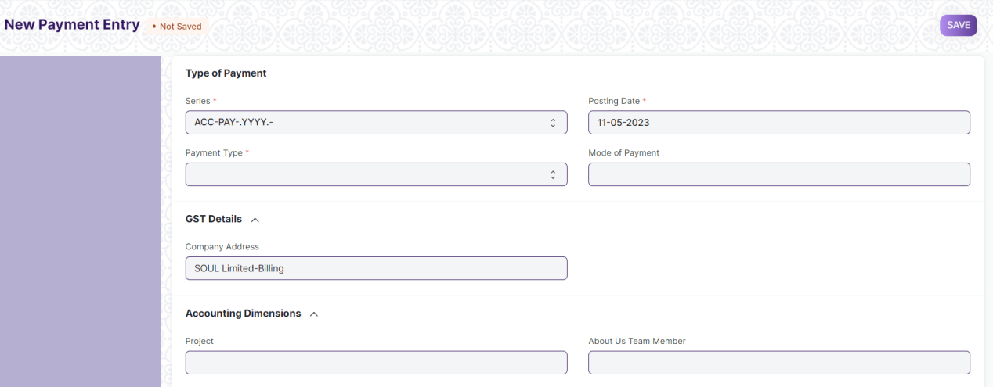Figure 14 : Payment Entry Screen

**Field List**

The following table describes the UI fields present in this screen :

|  |  |  |  |  |  |  |
| --- | --- | --- | --- | --- | --- | --- |
| **ID** | **Field Name** | **Type** | **Mandatory** | **Validation/ Action** | **Remarks** | **R = Rename**  **N= New**  **D= Delete** |
|  | Payment Type | Dropdown | Yes | Options:  Receive Pay Internal Transfer |  |  |
|  | Payment Order Status | Dropdown |  | Options:  Initiated  Payment Ordered |  |  |
|  | Posting Date | Date | Yes |  |  |  |
|  | Company | Link | Yes | Link Field to Company Screen |  |  |
|  | Mode of Payment | Link |  | Link Field to Mode of Payment Screen |  |  |
|  | Party Type | Link |  | Link Field to Employee, Customer, Student, Share holder, Supplier Screen |  |  |
|  | Party | Dynamic Link |  | On the basis of Party Type selected by the user, Dynamic Link Field will be visible accordingly. |  |  |
|  | Party Name | Text |  | Auto fetched when Party entered |  |  |
|  | Company Bank Account | Link |  | Link Field to Account Screen |  |  |
|  | Party Bank Account | Link |  | Link Field to Account Screen |  |  |
|  | Contact | Link |  | Link Field to Contact Screen |  |  |
|  | Email | Text |  |  |  |  |
|  | Party Balance | Currency |  |  |  |  |
|  | Account Paid From | Link | Yes | Link Field to Account Screen | When user entered payment type equal to Internal transfer then only this field will visible. |  |
|  | Paid From Account Type | Text |  |  |  |  |
|  | Account Currency (From) | Link | Yes | Link Field to Currency Screen | It will visible When Account Paid From data is entered |  |
|  | Account Balance (From) | Currency |  |  |  |  |
|  | Account Paid To | Link | Yes | Link Field to Currency Screen | When user entered payment type equal to Internal transfer then only this field will visible. |  |
|  | Paid To Account Type | Text |  |  |  |  |
|  | Account Currency (To) | Link | Yes | Link Field to Currency Screen | It will visible When Account Paid To data is entered |  |
|  | Account Balance (To) | Currency |  |  | It will visible When Account Paid To data is entered |  |
|  | Paid Amount | Currency | Yes |  | It will visible When Account Paid To data is entered |  |
|  | Paid Amount After Tax | Currency |  |  |  |  |
|  | Source Exchange Rate | Float | Yes |  |  |  |
|  | Paid Amount (Company Currency) | Currency | Yes |  |  |  |
|  | Paid Amount After Tax (Company Currency) | Currency |  |  |  |  |
|  | Received Amount | Currency | Yes |  | It will visible When Account Paid To data is entered |  |
|  | Received Amount After Tax | Currency |  |  |  |  |
|  | Target Exchange Rate | Float | Yes |  |  |  |
|  | Received Amount (Company Currency) | Currency | Yes |  |  |  |
|  | Received Amount After Tax (Company Currency) | Currency |  |  |  |  |
|  | Get Outstanding Invoice | Button |  |  |  |  |
|  | **Payment References** | Table |  |  |  |  |
|  | Total Allocated Amount | Currency |  |  |  |  |
|  | Total Allocated Amount (Company Currency) | Currency |  |  |  |  |
|  | Set Exchange Gain / Loss | Button |  |  |  |  |
|  | Unallocated Amount | Currency |  |  |  |  |
|  | Difference Amount (Company Currency) | Currency |  |  |  |  |
|  | Write Off Difference Amount | Button |  |  |  |  |
|  | Purchase Taxes and Charges Template | Link |  | Link Field to Purchase Taxes and Charges Template Screen |  |  |
|  | Sales Taxes and Charges Template | Link |  | Link Field to Sales Taxes and Charges Template Screen |  |  |
|  | Apply Tax Withholding Amount | Checkbox |  |  |  |  |
|  | Tax Withholding Category | Link |  | Link Field to Tax Withholding Category Screen |  |  |
|  | **Advance Taxes and Charges** | Table |  |  |  |  |
|  | Total Taxes and Charges (Company Currency) | Currency |  |  |  |  |
|  | Total Taxes and Charges | Currency |  |  |  |  |
|  | **Payment Deductions or Loss** | Table |  |  |  |  |
|  | Cheque/Reference No | Text |  |  | It will visible When Mode of Payment equals to Cheque |  |
|  | Cheque/Reference Date | Date |  |  | It will visible When Mode of Payment equals to Cheque |  |
|  | Clearance Date | Date |  |  |  |  |
|  | Project | Link |  | Link Field to Project Screen |  |  |
|  | Cost Center | Link |  | Link Field to Cost Center Screen |  |  |
|  | Status | Dropdown |  | Options:  Draft  Submitted  Cancelled |  |  |
|  | Remarks | Small Text |  |  |  |  |
|  | Letter Head | Link |  | Link Field to Company Screen |  |  |
|  | Print Heading | Link |  | Link Field to Company Screen |  |  |
|  | Bank | Read Only |  |  |  |  |
|  | Bank Account No | Read Only |  |  |  |  |
|  | Payment Order | Link |  | Link Field to Payment Order Screen |  |  |
|  | Auto Repeat | Link |  | Link Field to Auto Repeat Screen |  |  |
|  | Title | Text |  |  |  |  |

|  |  |  |  |  |  |  |
| --- | --- | --- | --- | --- | --- | --- |
| **Payment References** | | | | | | |
| **ID** | **Field Name** | **Type** | **Mandatory** | **Validation/ Action** | **Remarks** | **R=Rename**  **N= New**  **D= Delete** |
|  | Type | Link Field | Yes | Link Field to Supplier, Customer, Student, Employee Screen |  |  |
|  | Name | Dynamic Link Field | Yes | Dropdown data will come w.r.t. the Type |  |  |
|  | Due Date | Date |  |  |  |  |
|  | Supplier Invoice No | Text |  |  |  |  |
|  | Payment Term | Link Field |  | Link Field to Payment Term Screen |  |  |
|  | Grand Total | Float |  |  |  |  |
|  | Outstanding | Float |  |  |  |  |
|  | Allocated | Float |  |  |  |  |
|  | Exchange Rate | Float |  |  |  |  |
|  | Exchange Gain/Loss | Currency |  |  |  |  |
| **Advance Taxes and Charges** | | | | | | |
| **ID** | **Field Name** | **Type** | **Mandatory** | **Validation/ Action** | **Remarks** | **R=Rename**  **N= New**  **D= Delete** |
|  | Add Or Deduct | Dropdown | Yes | Option:  Add  Deduct |  |  |
|  | Type | Dropdown | Yes | Option:   1. Actual 2. On Paid Amount 3. On Previous Row Amount 4. On Previous Row Total |  |  |
|  | Account Head | Link | Yes | Link Filed to Account Screen |  |  |
|  | Description | Long Text | Yes |  |  |  |
|  | Considered In Paid Amount | Check Box |  | Link Field to Payment Term Screen |  |  |
|  | Cost Center | Link |  | Link field to Cost Center Screen |  |  |
|  | Rate | Float |  |  |  |  |
|  | Account Currency | Link |  | Link field to Currency Screen |  |  |
|  | Amount | Currency |  |  |  |  |
|  | Total | Currency |  |  |  |  |
|  | Allocated Amount | Currency |  |  |  |  |
| **Payment Deductions or Loss** | | | | | | |
| **ID** | **Field Name** | **Field Type** | **Mandatory** | **Validation/ Action** | **Remarks** | **R=Rename**  **N= New**  **D= Delete** |
|  | Account | Link | Yes | Link Field to Account Screen |  |  |
|  | Cost Center | Link | Yes | Link Field to Cost Center Screen |  |  |
|  | Amount | Currency | Yes |  |  |  |
|  | Description | Long Text |  |  |  |  |

**Users: Roles & Permission**

The following table describes the users and their roles and permissions for the screens :

|  |  |  |  |  |  |  |  |  |
| --- | --- | --- | --- | --- | --- | --- | --- | --- |
| **ID** | **Role** | **Read** | **Write** | **Create** | **Delete** | **Submit** | **Cancel** | **Amend** |
| 1 | Payroll Admin | Yes | Yes | Yes | Yes | Yes | Yes | Yes |
| 2 | Payroll User | Yes | Yes | Yes | No | Yes | No | No |
| 3 | HR Manager | No | No | No | No | No | No | No |
| 4 | Employee | No | No | No | No | No | No | No |

### 2.9 Employee Other Income

**General Description**

The following table describes overall information about this screen:

|  |  |
| --- | --- |
| **Description** | This screen is used by employee to declaration any source of side income they might have. |
| **Navigation** | Home > Payroll > Taxation > Employee Tax Exemption Proof Submission |
| **Pre-requisites** | The system should have records in the following screen:   1. Employee 2. Company 3. Payroll Period |
| **Existing Screen Name** | Employee Other Income |
| **New Screen Name** | No change |

**Screenshot**

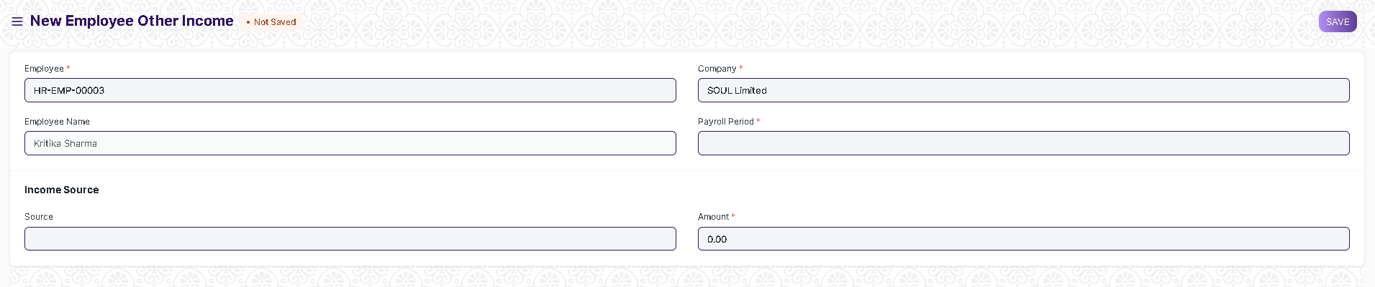

Figure 15 : Employee Other Income

**Field List**

The following table describes the UI fields present in this screen :

|  |  |  |  |  |  |  |
| --- | --- | --- | --- | --- | --- | --- |
| **ID** | **Field Name** | **Field Type** | **Mandatory** | **Validation/Action** | **Remarks** | **R = Rename ,**  **N = New ,**  **D =Delete** |
| 1 | Employee | Link | Yes | Links to Employee Master Screen |  |  |
| 2 | Employee Name | Text |  | This is a read only and field and is filled as per employee selected |  |  |
| 3 | Company | Link |  | This is a read only and field and is filled as per employee selected |  |  |
| 4 | Payroll Period | Link | Yes | Links to Payroll Period Master Screen. |  |  |
| 5 | Source | Text |  |  |  |  |
| 6 | Amount | Currency |  |  |  |  |

**Users: Roles and Permissions**

The following table describes the users and their roles and permissions for the screens :

|  |  |  |  |  |  |  |  |  |
| --- | --- | --- | --- | --- | --- | --- | --- | --- |
| **ID** | **Role** | **Read** | **Write** | **Create** | **Delete** | **Submit** | **Cancel** | **Amend** |
| 1 | Payroll Admin | Yes | Yes | Yes | Yes | Yes | Yes | Yes |
| 2 | Payroll User | Yes | Yes | Yes | No | Yes | No | No |
| 3 | HR Manager | Yes | Yes | Yes | No | No | No | No |
| 4 | Employee | No | No | No | No | No | No | No |

### 2.10 Employee Tax Exemption Category

**General Description**

The following table describes overall information about this screen:

|  |  |
| --- | --- |
| **Description** | 1. This screen describes or define the employee tax categories and maximum exemption amount allowed. 2. Exemptions from taxable salary are usually restricted to spendings on particular categories decided by the Government or regulatory agencies. |
| **Navigation** | Home >Payroll>Taxation> Employee Tax Exemption Category |
| **Pre-requisites** | NA |
| **Existing Screen Name** | Employee Tax Exemption Category |
| **New Screen Name** | No change |

**Screenshot**

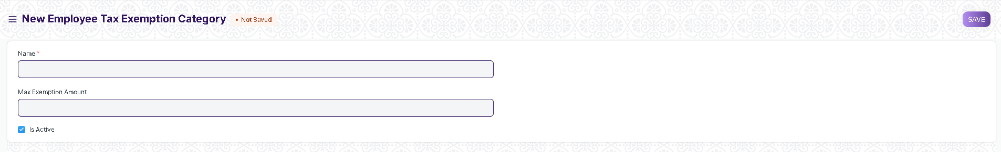

Figure 16: Employee Tax Exemption Category

**Field List**

The following table describes the UI fields present in this screen :

|  |  |  |  |  |  |  |
| --- | --- | --- | --- | --- | --- | --- |
| **ID** | **Field Name** | **Field Type** | **Mandatory** | **Validation/Action** | **Remarks** | **R = Rename ,**  **N = New ,**  **D =Delete** |
| 1 | Name | Text | Yes |  |  |  |
| 2 | Max Exemption Amount | Currency |  |  |  |  |
| 3 | Is Active | Checkbox |  | If this checkbox is checked the category will appear as a option in link fields |  |  |

**Users: Roles and Permissions**

The following table describes the users and their roles and permissions for the screens :

|  |  |  |  |  |  |  |  |  |
| --- | --- | --- | --- | --- | --- | --- | --- | --- |
| **ID** | **Role** | **Read** | **Write** | **Create** | **Delete** | **Submit** | **Cancel** | **Amend** |
| 1 | Payroll Admin | Yes | Yes | Yes | Yes | NA | NA | NA |
| 2 | Payroll User | Yes | Yes | Yes | No | NA | NA | NA |
| 3 | HR Manager | Yes | Yes | Yes | No | NA | NA | NA |
| 4 | Employee | No | No | No | No | NA | NA | NA |

### 2.11 Employee Tax Exemption Sub-Category

**General Description**

The following table describes overall information about this screen:

|  |  |
| --- | --- |
| **Description** | 1. Under a Tax Exemption category there could be multiple sub-categories for exemption. These sub-categories are defined in the Employee Tax Exemption Sub-Category Screen. 2. The maximum exemption for the subcategory is also set in this screen |
| **Navigation** | Home > Payroll > Taxation > Employee Tax Exemption Sub-Category |
| **Pre-requisites** | The system should have records in the following screen:   1. Employee Tax Exemption Category |
| **Existing Screen Name** | Employee Tax Exemption Sub-Category |
| **New Screen Name** | No Change |

**Screenshot**

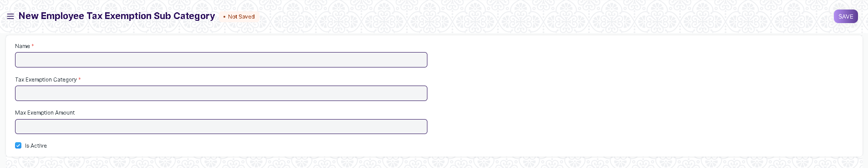

Figure 17:Employee Tax Exemption Sub-Category

**Field List**

The following table describes the UI fields present in this screen :

|  |  |  |  |  |  |  |
| --- | --- | --- | --- | --- | --- | --- |
| **ID** | **Field Name** | **Field Type** | **Mandatory** | **Validation/Action** | **Remarks** | **R = Rename ,**  **N = New ,**  **D =Delete** |
| 1 | Name | Text | Yes |  |  |  |
| 2 | Tax Exemption Category | Link | Yes | Links to Employee Tax Exemption Category |  |  |
| 2 | Max Exemption Amount | Currency |  |  |  |  |
| 3 | Is Active | Checkbox |  | If this checkbox is checked the category will appear as a option in link fields of exemption sub-category |  |  |

**Users: Roles and Permissions**

The following table describes the users and their roles and permissions for the screens :

|  |  |  |  |  |  |  |  |  |
| --- | --- | --- | --- | --- | --- | --- | --- | --- |
| **ID** | **Role** | **Read** | **Write** | **Create** | **Delete** | **Submit** | **Cancel** | **Amend** |
| 1 | Payroll Admin | Yes | Yes | Yes | Yes | NA | NA | NA |
| 2 | Payroll User | Yes | Yes | Yes | No | NA | NA | NA |
| 3 | HR Manager | Yes | Yes | Yes | No | NA | NA | NA |
| 4 | Employee | Yes | No | No | No | NA | NA | NA |

### 2.12 Employee Tax Exemption Declaration

**General Description**

The following table describes overall information about this screen:

|  |  |
| --- | --- |
| **Description** | This screen is used to record employee tax exemption application |
| **Navigation** | Home > Payroll > Taxation > Employee Tax Exemption Declaration |
| **Pre-requisites** | The system should have records in the following screen:   1. Employee 2. Currency 3. Department 4. Company 5. Payroll Period 6. Employee Tax Exemption Category 7. Employee Tax Exemption Sub-Category |
| **Existing Screen Name** | Employee Tax Exemption Declaration |
| **New Screen Name** | No change |

**Screenshot**

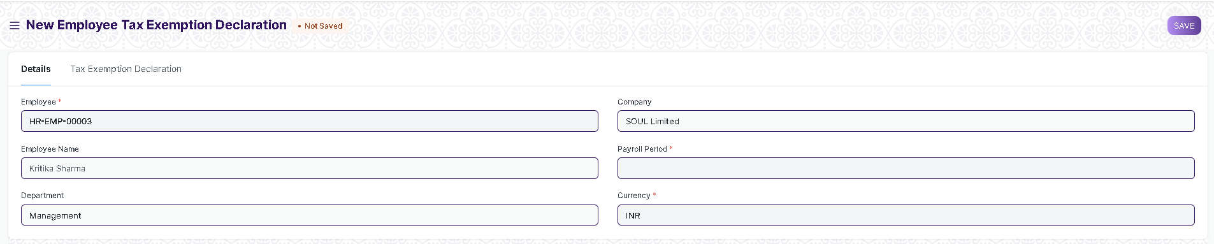

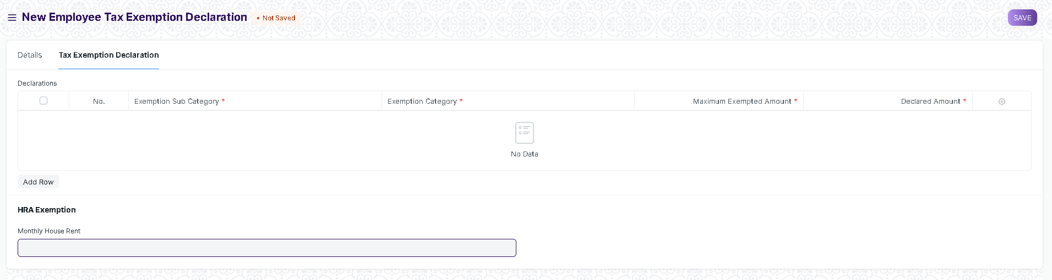

Figure 18: Employee Tax Exemption Declaration

**Field List**

The following table describes the UI fields present in this screen :

|  |  |  |  |  |  |  |
| --- | --- | --- | --- | --- | --- | --- |
| **ID** | **Field Name** | **Field Type** | **Mandatory** | **Validation/Action** | **Remarks** | **R = Rename ,**  **N = New ,**  **D =Delete** |
| 1 | Employee | Link | Yes | Links to Employee Master Screen |  |  |
| 2 | Employee Name | Text |  | This is a read only and field and is filled as per employee selected |  |  |
| 3 | Department | Link |  | This is a read only and field and is filled as per employee selected |  |  |
| 3 | Company | Link |  | This field is also a read only field and filled as per employee selected |  |  |
| 4 | Payroll Period | Link | Yes | Links to Payroll Period Master Screen |  |  |
| 5 | Currency | Link | Yes | Links to Currency Master Screen |  |  |
| **Tab Break(Tax Exemptions)** | | | | | | |
| 6 | **Declarations** | Table | Yes |  | This table is described below |  |
| 7 | Monthly House Rent | Currency |  |  |  |  |
| 8 | Annual HRA Exemption | Currency |  |  |  |  |
| 9 | Monthly HRA Exemption | Currency |  |  |  |  |
| 10 | HRA as per Salary Structure | Currency |  |  |  |  |
| 11 | Rented in Metro City | Checkbox |  |  |  |  |
| 12 | Total Declared Amount | Currency |  |  |  |  |
| 13 | Total Exemption Amount | Currency |  |  |  |  |
| 14 | Submit Proof | Button |  | On clicking this button it redirects the user to Employee Tax Exemption Submission |  |  |
| **Declarations** | | | | | | |
| **ID** | **Field Name** | **Field Type** | **Mandatory** | **Validation/Action** | **Remarks** | **R = Rename ,**  **N = New ,**  **D =Delete** |
| 15 | Exemption Sub-Category | Link | Yes | This field links to exemption sub-category screen |  |  |
| 16 | Exemption Category | Link | Yes | This field links to exemption category and is a read-only field which is filled as per exemption sub-category selected |  |  |
| 17 | Maximum Exempted Amount | Currency | Yes | This is a read-only field that is filled as per exemption sub-category selected |  |  |
| 18 | Declared Amount | Currency | Yes |  |  |  |

**Users: Roles and Permissions**

The following table describes the users and their roles and permissions for the screens :

|  |  |  |  |  |  |  |  |  |
| --- | --- | --- | --- | --- | --- | --- | --- | --- |
| **ID** | **Role** | **Read** | **Write** | **Create** | **Delete** | **Submit** | **Cancel** | **Amend** |
| 1 | Payroll Admin | Yes | Yes | Yes | Yes | Yes | No | No |
| 2 | Payroll User | Yes | Yes | Yes | No | NA | No | No |
| 3 | HR Manager | Yes | Yes | Yes | No | NA | No | No |
| 4 | Employee | Yes | Yes | Yes | No | Yes | No | No |

### 2.13 Employee Tax Exemption Proof Submission

**General Description**

The following table describes overall information about this screen:

|  |  |
| --- | --- |
| **Description** | This screen is used to confirm and submit proof regarding tax exemption declaration |
| **Navigation** | Home > Payroll > Taxation > Employee Tax Exemption Proof Submission |
| **Pre-requisites** | The system should have records in the following screen:   1. Employee 2. Currency 3. Department 4. Company 5. Payroll Period 6. Employee Tax Exemption Category 7. Employee Tax Exemption Sub-Category 8. Employee Tax Exemption Declaration |
| **Existing Screen Name** | Employee Tax Exemption Proof Submission |
| **New Screen Name** | No change |

**Screenshot**

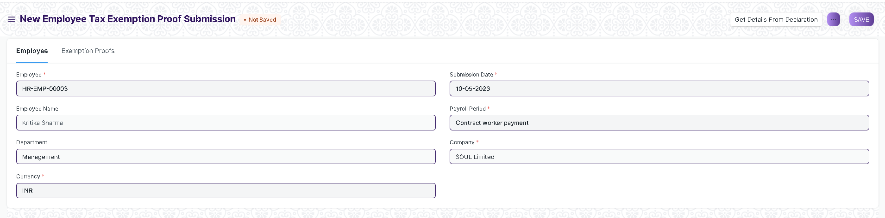

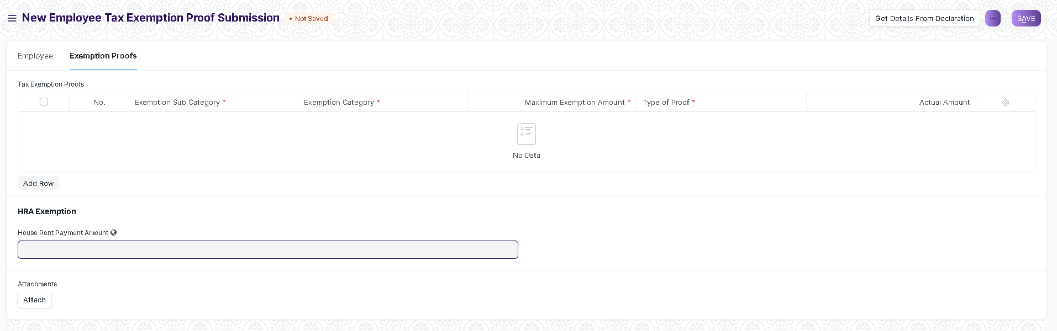

Figure 19 : Employee Tax Exemption Proof Submission

**Field List**

The following table describes the UI fields present in this screen :

|  |  |  |  |  |  |  |
| --- | --- | --- | --- | --- | --- | --- |
| **ID** | **Field Name** | **Field Type** | **Mandatory** | **Validation/Action** | **Remarks** | **R = Rename ,**  **N = New ,**  **D =Delete** |
| 1 | Employee | Link | Yes | Links to Employee Master Screen |  |  |
| 2 | Employee Name | Text |  | This is a read only and field and is filled as per employee selected |  |  |
| 3 | Department | Link |  | This is a read only and field and is filled as per employee selected |  |  |
| 3 | Company | Link |  | This field is also a read only field and filled as per employee selected |  |  |
| 4 | Payroll Period | Link | Yes | Links to Payroll Period Master Screen. |  |  |
| 5 | Currency | Link | Yes | Links to Currency Master Screen |  |  |
| 6 | Submission Date | Date | Yes |  |  |  |
| **Tab Break(Exemptions Proofs)** | | | | | | |
| 6 | **Tax Exemption Proof** | Table | Yes |  | This table is described below |  |
| 7 | House Rent Payment Amount | Currency |  |  |  |  |
| 8 | Monthly House Rent | Currency |  |  |  |  |
| 9 | Rented From Date | Date |  |  |  |  |
| 10 | Rented To Date | Date |  |  |  |  |
| 11 | Monthly Eligible Amount | Currency |  |  |  |  |
| 12 | Total Eligible HRA Exemption | Currency |  |  |  |  |
| 13 | Rented in Metro City | Checkbox |  |  |  |  |
| 14 | Total Actual Amount | Currency |  |  |  |  |
| 15 | Total Exemption Amount | Currency |  |  |  |  |
| 16 | Attachments | Attach |  | To provide a Hard copy of Tax exemption proof document |  |  |
| **Tax Exemption Proof** | | | | | | |
| **ID** | **Field Name** | **Field Type** | **Mandatory** | **Validation/Action** | **Remarks** | **R = Rename ,**  **N = New ,**  **D =Delete** |
| 16 | Exemption Sub-Category | Link | Yes | This field links to exemption sub-category screen |  |  |
| 17 | Exemption Category | Link | Yes | This field links to exemption category and is a read-only field which is filled as per exemption sub-category selected |  |  |
| 18 | Maximum Exempted Amount | Currency | Yes | This is a read-only field that is filled as per exemption sub-category selected |  |  |
| 19 | Declared Amount | Currency | Yes |  |  |  |
| 20 | Type of Proof | Text | Yes |  |  |  |

**Users: Roles and Permissions**

The following table describes the users and their roles and permissions for the screens :

|  |  |  |  |  |  |  |  |  |
| --- | --- | --- | --- | --- | --- | --- | --- | --- |
| **ID** | **Role** | **Read** | **Write** | **Create** | **Delete** | **Submit** | **Cancel** | **Amend** |
| 1 | Payroll Admin | Yes | Yes | Yes | Yes | Yes | Yes | Yes |
| 2 | Payroll User | Yes | Yes | Yes | No | No | No | No |
| 3 | HR Manager | Yes | Yes | Yes | No | No | No | No |
| 4 | Employee | Yes | Yes | Yes | No | Yes | No | No |

### 2.14 Additional Salary

**General Description**

The following table describes overall information about this screen:

|  |  |
| --- | --- |
| **Description** | Additional Salary is something that an Employee receives from the company they work for, other than their usual pay. |
| **Navigation** | Home > Payroll > Compensation > Additional Salary |
| **Pre-requisites** | The system should have records in the following screen:   1. Salary Component 2. Employee 3. Company 4. Payroll Period |
| **Existing Screen Name** | Additional Salary |
| **New Screen Name** | No change |

**Screenshot**

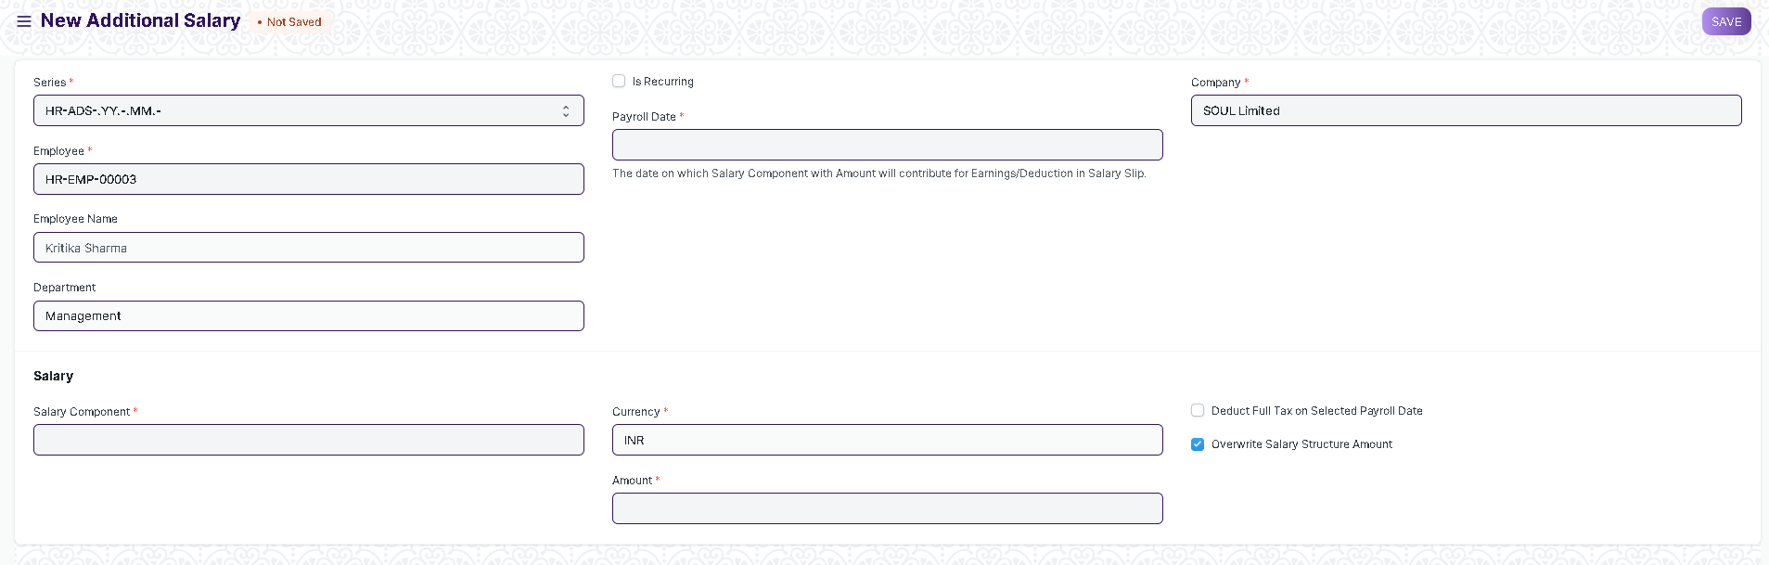

Figure 20: Additional Salary

**Field List**

The following table describes the UI fields present in this screen :

|  |  |  |  |  |  |  |
| --- | --- | --- | --- | --- | --- | --- |
| **ID** | **Field Name** | **Field Type** | **Mandatory** | **Validation/Action** | **Remarks** | **R = Rename ,**  **N = New ,**  **D =Delete** |
| 1 | Series | Dropdown | Yes | HR-ADS-.YY.-.MM.- | Contains naming options |  |
| 2 | Employee | Link | Yes | Links to Employee Master Screen |  |  |
| 3 | Employee Name | Text |  | This is a read only and field and is filled as per employee selected |  |  |
| 4 | Department | Link |  | This is a read only and field and is filled as per employee selected |  |  |
| 5 | Company | Link | Yes | This is a read only and field and is filled as per employee selected |  |  |
| 6 | Payroll Date | Date | Yes |  |  |  |
| 7 | Is Recurring | Checkbox |  | If Additional Salary will recurring then tick this checkbox , If checked the payroll date is replaced by From_date and to_date |  |  |
| 8 | From Date | Date | Yes | Only Appears if “Is Recurring ”Checkbox is checked |  |  |
| 9 | To Date | Date | Yes | Only Appears if “Is Recurring ”Checkbox is checked |  |  |
| 10 | Salary Component | Link | Yes | Links to Salary Component Screen |  |  |
| 11 | Currency | Link | Yes | Links to Currency Master Screen |  |  |
| 12 | Amount | Currency | Yes |  |  |  |
| 13 | Salary Component Type | Data |  | A read-only field , appears as per salary component selected |  |  |
| 14 | Deduct Full Tax of Selected Payroll Date | Checkbox |  | If checked taxes will be deducted from additional salary |  |  |
| 15 | Overwrite Salary Structure Amount | Checkbox |  |  |  |  |

**Users: Roles and Permissions**

The following table describes the users and their roles and permissions for the screens :

|  |  |  |  |  |  |  |  |  |
| --- | --- | --- | --- | --- | --- | --- | --- | --- |
| **ID** | **Role** | **Read** | **Write** | **Create** | **Delete** | **Submit** | **Cancel** | **Amend** |
| 1 | Payroll Admin | Yes | Yes | Yes | Yes | Yes | Yes | Yes |
| 2 | Payroll User | Yes | Yes | Yes | No | No | No | No |
| 3 | HR Manager | Yes | Yes | Yes | No | No | No | No |
| 4 | Employee | Yes | No | No | No | No | No | No |

### 2.15 Retention Bonus

**General Description**

The following table describes overall information about this screen:

|  |  |
| --- | --- |
| **Description** | Retention bonus is a payment or reward outside of an employee's regular salary that is offered as an incentive to keep a key employee on the job. |
| **Navigation** | Home > Payroll > Compensation > Retention Bonus |
| **Pre-requisites** | The system should have records in the following screen:   1. Employee 2. Department 3. Salary Component 4. Company |
| **Existing Screen Name** | Retention Bonus |
| **New Screen Name** | No change |

**Screenshot**

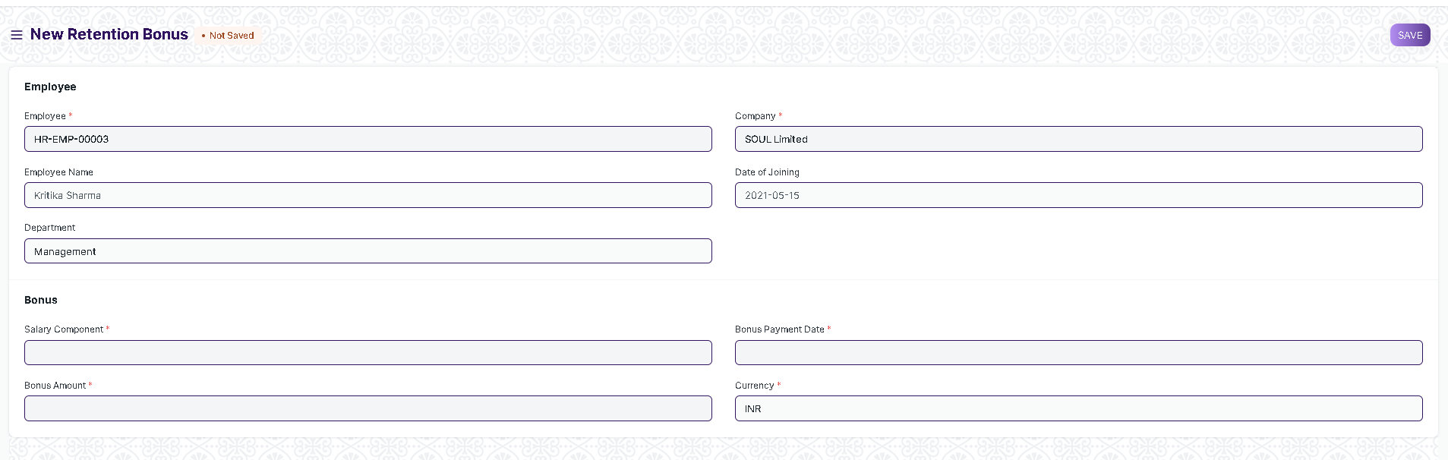

Figure 21 :Retention Bonus

**Field List**

The following table describes the UI fields present in this screen :

|  |  |  |  |  |  |  |
| --- | --- | --- | --- | --- | --- | --- |
| **ID** | **Field Name** | **Field Type** | **Mandatory** | **Validation/Action** | **Remarks** | **R = Rename ,**  **N = New ,**  **D =Delete** |
| 1 | Employee | Link | Yes | Links to Employee Master Screen |  |  |
| 2 | Employee Name | Text |  | This is a read only and field and is filled as per employee selected |  |  |
| 3 | Department | Link |  | This is a read only and field and is filled as per employee selected |  |  |
| 4 | Company | Link | Yes | This is a read only and field and is filled as per employee selected |  |  |
| 5 | Date of joining | Date |  | This is a read only and field and is filled as per employee selected |  |  |
| 6 | Salary Component | Link | Yes | Links to Salary Component Screen |  |  |
| 7 | Currency | Link | Yes | Links to Currency Master Screen |  |  |
| 8 | Bonus Payment Date | Date |  |  |  |  |
| 9 | Bonus Amount | Currency |  |  |  |  |

**Users: Roles and Permissions**

The following table describes the users and their roles and permissions for the screens :

|  |  |  |  |  |  |  |  |  |
| --- | --- | --- | --- | --- | --- | --- | --- | --- |
| **ID** | **Role** | **Read** | **Write** | **Create** | **Delete** | **Submit** | **Cancel** | **Amend** |
| 1 | Payroll Admin | Yes | Yes | Yes | Yes | Yes | Yes | Yes |
| 2 | Payroll User | Yes | Yes | Yes | No | No | No | No |
| 3 | HR Manager | Yes | Yes | Yes | No | No | No | No |
| 4 | Employee | Yes | No | No | No | No | No | No |

### 2.15 Employee Incentive

**General Description**

The following table describes overall information about this screen:

|  |  |
| --- | --- |
| **Description** | 1. Employee Incentives are a way of compensating and motivating employee performance apart from the usual salary. 2. When an organization wants to encourage productivity among its employees, one of the options available is rewarding the Employee with an incentive. |
| **Navigation** | Home > Payroll > Compensation > Employee Incentive |
| **Pre-requisites** | The system should have records in the following screen:   1. Employee 2. Salary Component 3. Company |
| **Existing Screen Name** | Employee Incentive |
| **New Screen Name** | None |

**Screenshot**

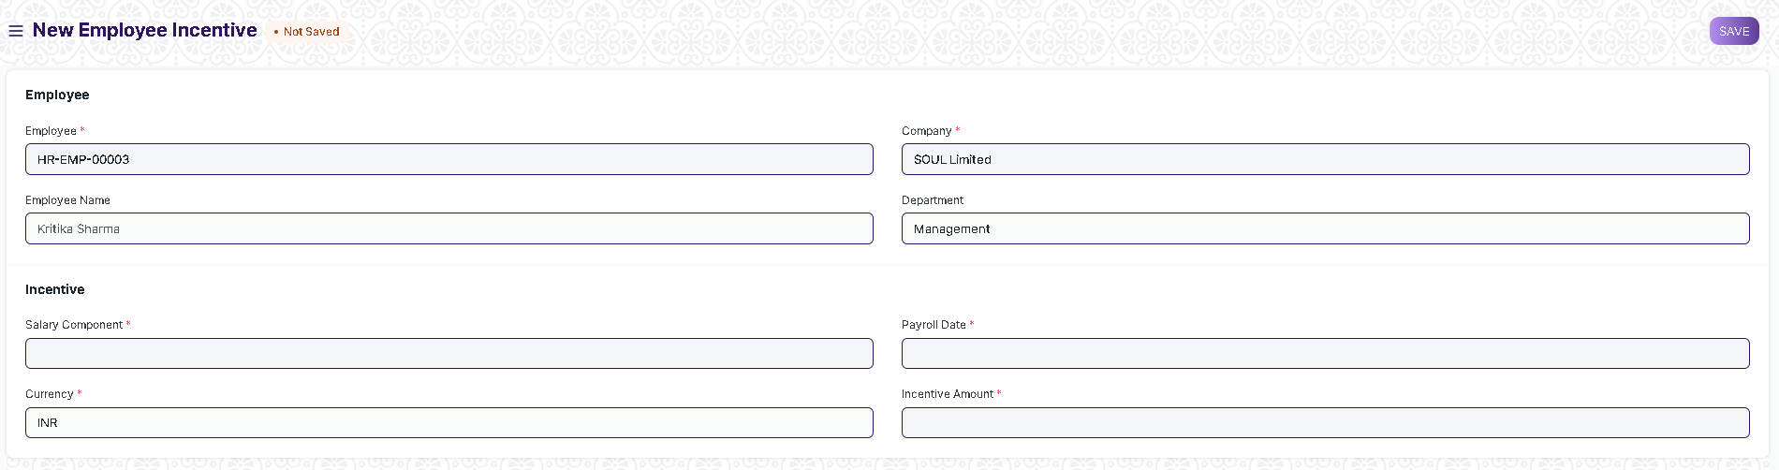

Figure 22 : Employee Incentive

**Field List**

The following table describes the UI fields present in this screen :

|  |  |  |  |  |  |  |
| --- | --- | --- | --- | --- | --- | --- |
| **ID** | **Field Name** | **Field Type** | **Mandatory** | **Validation/Action** | **Remarks** | **R = Rename ,**  **N = New ,**  **D =Delete** |
| 1 | Employee | Link | Yes | Links to Employee Master Screen |  |  |
| 2 | Employee Name | Text |  | This is a read only and field and is filled as per employee selected |  |  |
| 3 | Department | Link |  | This is a read only and field and is filled as per employee selected |  |  |
| 4 | Company | Link | Yes | This is a read only and field and is filled as per employee selected |  |  |
| 5 | Salary Component | Link | Yes | Links to Salary Component Screen |  |  |
| 6 | Payroll Date | Date |  |  |  |  |
| 7 | Incentive Amount | Currency |  |  |  |  |

**Users: Roles and Permissions**

The following table describes the users and their roles and permissions for the screens :

|  |  |  |  |  |  |  |  |  |
| --- | --- | --- | --- | --- | --- | --- | --- | --- |
| **ID** | **Role** | **Read** | **Write** | **Create** | **Delete** | **Submit** | **Cancel** | **Amend** |
| 1 | Payroll Admin | Yes | Yes | Yes | Yes | Yes | Yes | Yes |
| 2 | Payroll User | Yes | Yes | Yes | No | No | No | No |
| 3 | HR Manager | Yes | Yes | Yes | No | No | No | No |
| 4 | Employee | Yes | No | No | No | No | No | No |

### 2.16 Employee Benefit Application

**General Description**

The following table describes overall information about this screen:

|  |  |
| --- | --- |
| **Description** | 1. Employees are entitled to flexible benefits which they can either receive pro-rata (as part of their Salary) or as a lump-sum amount when they claim the benefit. In order to choose from various flexible benefits which an Employee shall receive on a pro-rata basis, the employee should create a new Employee Benefit Application. |
| **Navigation** | Home > Payroll > Compensation > Employee Benefit Application |
| **Pre-requisites** | The system should have records in the following screen:   1. Employee 2. Department 3. Salary Component 4. Company |
| **Existing Screen Name** | Employee Incentive |
| **New Screen Name** | No Change |

**Screenshot**

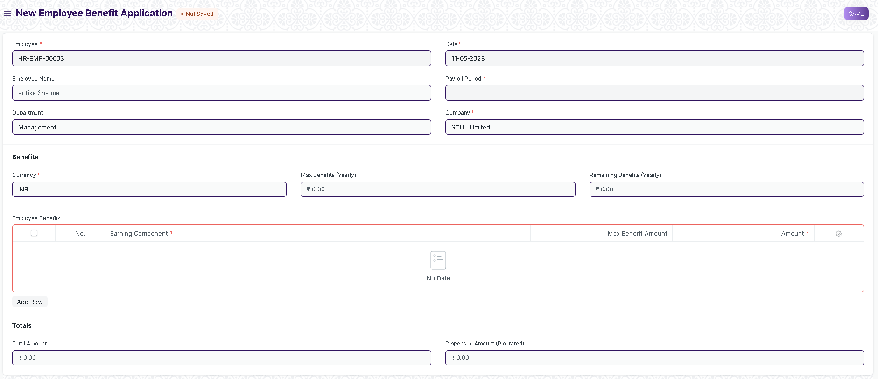

Figure 23 : Employee Benefit Application

**Field List**

The following table describes the UI fields present in this screen :

|  |  |  |  |  |  |  |
| --- | --- | --- | --- | --- | --- | --- |
| **ID** | **Field Name** | **Field Type** | **Mandatory** | **Validation/Action** | **Remarks** | **R = Rename ,**  **N = New ,**  **D =Delete** |
| 1 | Employee | Link | Yes | Links to Employee Master Screen |  |  |
| 2 | Employee Name | Text |  | This is a read only and field and is filled as per employee selected |  |  |
| 3 | Department | Link |  | This is a read only and field and is filled as per employee selected |  |  |
| 4 | Company | Link | Yes | This is a read only and field and is filled as per employee selected |  |  |
| 5 | Date | Date | Yes |  |  |  |
| 6 | Payroll Period | Link | Yes | Links to Payroll Period Master Screen |  |  |
| 7 | Currency | Link | Yes | Links to Currency Master Screen |  |  |
| 8 | Max Benfit(Year) | Currency |  | This is a read only and field and is filled as per employee selected |  |  |
| 9 | Remaining Benefits | Currency |  | This is a read only and field and is filled as per employee selected |  |  |
| 10 | **Employee Benefits** | Table |  | Details Regarding the table are given below |  |  |
| 11 | Total Amount | Currency |  |  |  |  |
| 12 | Dispensed Amount(Pro-Rated) | Currency |  |  |  |  |
| **Employee Benefits** | | | | | | |
| **ID** | **Field Name** | **Field Type** | **Mandatory** | **Validation/Action** | **Remarks** | **R = Rename ,**  **N = New ,**  **D =Delete** |
| 13 | Earning Component | Link | Yes | This field links to Salary Component Master Screen and options will be visible as per salary components assigned to that employee |  |  |
| 14 | Max Benefit Amount | Currency | Yes | This is a read only and field and is filled as per salary component selected |  |  |
| 15 | Amount | Currency | Yes | In this field the amount that will be dispensed for a specific salary component is to be entered |  |  |
| 16 | Pay against Benefit Claim | Checkbox |  | Read only field , will be filled as per salary component selected |  |  |

**Users: Roles and Permissions**

The following table describes the users and their roles and permissions for the screens :

|  |  |  |  |  |  |  |  |  |
| --- | --- | --- | --- | --- | --- | --- | --- | --- |
| **ID** | **Role** | **Read** | **Write** | **Create** | **Delete** | **Submit** | **Cancel** | **Amend** |
| 1 | Payroll Admin | Yes | Yes | Yes | Yes | Yes | Yes | Yes |
| 2 | Payroll User | Yes | Yes | Yes | No | No | No | No |
| 3 | HR Manager | Yes | Yes | Yes | No | No | No | No |
| 4 | Employee | Yes | Yes | Yes | No | No | No | No |

### 2.17 Employee Benefit Claim

**General Description**

The following table describes overall information about this screen:

|  |  |
| --- | --- |
| **Description** | Employee Benefit Claim allows Employees to -   1. Claim flexible benefits which are to be received lump-sum (if Salary Component is Pay Against Benefit Claim) 2. Claim tax exemption for flexible benefits received pro-rata, as part of salary when Deduct Tax For Unclaimed Employee Benefits is checked in Payroll Entry / Salary Slip |
| **Navigation** | Home > Payroll > Compensation > Employee Benefit Claim |
| **Pre-requisites** | The system should have records in the following screen:   1. Employee 2. Department 3. Salary Component 4. Company |
| **Existing Screen Name** | Employee Incentive |
| **New Screen Name** | No Change |

**Screenshot**

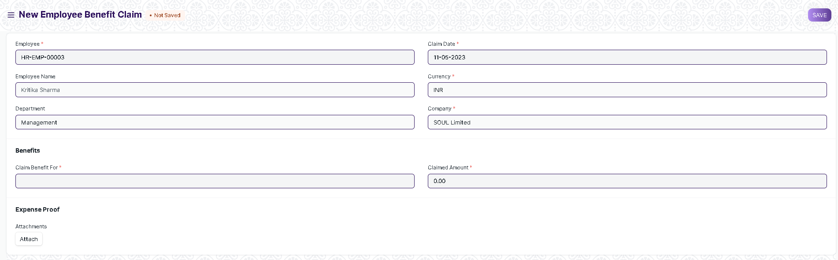

Figure 24: Employee Benefit Claim

**Field List**

The following table describes the UI fields present in this screen :

|  |  |  |  |  |  |  |
| --- | --- | --- | --- | --- | --- | --- |
| **ID** | **Field Name** | **Field Type** | **Mandatory** | **Validation/Action** | **Remarks** | **R = Rename ,**  **N = New ,**  **D =Delete** |
| 1 | Employee | Link | Yes | Links to Employee Master Screen |  |  |
| 2 | Employee Name | Text |  | This is a read only and field and is filled as per employee selected |  |  |
| 3 | Department | Link |  | This is a read only and field and is filled as per employee selected |  |  |
| 4 | Company | Link | Yes | This is a read only and field and is filled as per employee selected |  |  |
| 5 | Currency | Link | Yes | Links to Currency Master Screen |  |  |
| 6 | Claim Date | Date | Yes |  |  |  |
| 7 | Claim Benefit For | Link | Yes | Links to Salary Component Master Screen |  |  |
| 8 | Max Amount Eligible | Currency |  |  |  |  |
| 9 | Pay against Benefit Claim | Checkbox |  | Read only field , will be filled as per salary component selected |  |  |
| 10 | Claimed Amount | Currency |  |  |  |  |
| 11 | Salary Slip | Link |  | Links to Salary Screen Slips and is only visible after payroll entry |  |  |
| 12 | Attachments | Attach |  |  | Can be used to upload proof against the benefit claims |  |

**Users: Roles and Permissions**

The following table describes the users and their roles and permissions for the screens :

|  |  |  |  |  |  |  |  |  |
| --- | --- | --- | --- | --- | --- | --- | --- | --- |
| **ID** | **Role** | **Read** | **Write** | **Create** | **Delete** | **Submit** | **Cancel** | **Amend** |
| 1 | Payroll Admin | Yes | Yes | Yes | Yes | Yes | Yes | Yes |
| 2 | Payroll User | Yes | Yes | Yes | No | No | No | No |
| 3 | HR Manager | Yes | Yes | Yes | No | No | No | No |
| 4 | Employee | Yes | Yes | Yes | No | No | No | No |